THE DEVELOPMENT AND VALIDATION OF A CABLE DRIVEN, UNDERACTUATED KNEE-BACK EXOSKELETON FOR REDUCTION IN MUSCLE ACTIVATION AND METABOLIC COST IN LIFTING

A Dissertation
Presented to
The Academic Faculty

by

Chase Sun

In Partial Fulfillment
of the Requirements for the Degree
Master of Science in the
Woodruff School of Mechanical Engineering
College of Engineering

Georgia Institute of Technology

August 2026

Copyright © 2026 by Chase Sun

THE DEVELOPMENT AND VALIDATION OF A CABLE DRIVEN, UNDERACTUATED KNEE-BACK EXOSKELETON FOR REDUCTION IN MUSCLE ACTIVATION AND METABOLIC COST IN LIFTING

Approved by:
Dr. Aaron Young, Advisor
School of Mechanical Engineering
Georgia Institute of Technology
Dr. Tony Chen
School of Mechanical Engineering
Georgia Institute of Technology
Dr. David MacNair
School of Mechanical Engineering
Georgia Institute of Technology
Date Approved:

ACKNOWLEDGEMENTS

TABLE OF CONTENTS
ACKNOWLEDGEMENTS iv
LIST OF TABLES vii
LIST OF FIGURES viii
LIST OF SYMBOLS AND ABBREVIATIONS ix
SUMMARY xii
CHAPTER 1. Introduction 1
1.1 Mechanics of Workplace Injury 1
1.2 Assistive Exoskeleton Prior Art 2
1.2.1 Passive Assistive Devices Prior Art 2
1.2.2 Active Assistive Devices Prior Art 4
1.3 Underactuated Exoskeletons 5
1.4 Novel Solution 7
1.5 Outline of Following Sections 8
CHAPTER 2. EXOSKELETON DESIGN 9
2.1 Biomechanical Simulation 9
2.2 Design Overview 11
2.3 Functional Components 12
2.3.1 Back Component 13
2.3.2 Thigh Component 14
2.3.3 Shank Component 15
2.3.4 Design Summary 16
2.4 Assistive Element Selection 16
2.4.1 Passive Element 16
2.4.2 Active Element 17
2.5 Sensors and Electronics 18
2.6 Closed Loop Controller 19
2.6.1 High Level Controller 19
2.6.2 Mid And Low-Level Controller 20
2.7 Cable Force Tracking 22
CHAPTER 3. Human Subject Testing 23
3.1 Experimental Protocol 23
3.2 Data Analysis 27
3.3 Statistical Analysis 29
CHAPTER 4. Results 30
4.1 Metabolic Cost 30
4.2 Electromyography 30
4.3 Subject Reported Metrics 31
4.4 No Exo Comparison 33
CHAPTER 5. Discussion 34
5.1 Study Summary 34
5.2 Highlight Results 34
5.3 Symmetrical Lifting 35
5.4 Asymmetric Lifting 36
5.5 Design Limitations 37
5.6 Study Limitations 38
CHAPTER 6. Conclusion 39
REFERENCES 40

LIST OF FIGURES
Figure 1 | Simulated biological kinetic and kinematic trajectories alongside offloading assistance during a lifting task where a representative median subject lifts a 35lb kettlebell from the ground to waist height. (Left) Lumbar extension biological moment (solid blue line), simulated exoskeleton linear displacement (dotted red line), and simulated exoskeleton assistance moment (dash-dotted green line) across a single normalized lift duration. (Right) Right knee extension biological moment, composite band angle, and simulated exoskeleton assistance moment across the normalized lift cycle. Shaded bounds depict ± 1 standard deviation (SD) across 7 repetitions. Biological extension torques at both the lumbosacral and knee joints track closely with the total simulated exoskeleton displacement across all N=10 subjects simulated. total exoskeleton displacement is calculated using Equation (1) and exoskeleton assistance torque is calculated by scaling total displacement with linear stiffness. Simulated exoskeleton covers roughly ~20% of biological joint moment at the lumbar and ~30% joint moment at the knee. | 10
Figure 2 | CAD renderings of the design show all major components of the device as well as both active (green) and passive (purple) cable paths of the right side of the exoskeleton through a transparent view. | 12
Figure 3 | Pilot wearing the exoskeleton while engaging in lifting, with cable paths highlighted on the left side. | 13
Figure 4 | Block diagram of the exoskeleton’s active assistance controls. The finite state machine (FSM) determines stiffness (K) and damping coefficient (B) from joint kinematics and provides them to the impedance controller, which computes required linear force assistance in line scaled by subject mass and exo torque moment arm. The admittance controller computes the error between commanded and measured force from load cells to calculate required velocity command, assisted by the feed-forward controller to account for cable displacement from joint motion. The PD controller then uses encoder velocity feedback to command actuator torque to assist the wearer’s motion. | 19
Figure 5 | Cable tension tracking and combined joint kinematics across dynamic finite state machine (FSM) control states during a representative lifting task with maximum force normalized RMSE of 10.22%. (Left Y-Axis) Target commanded force (dashed orange line), right-side measured force (solid blue line), and left-side measured force (dash-dotted green line) averaged across valid lift cycles. (Right Y-Axis) Right-side combined joint angle (dotted purple line). Background shaded regions and vertical dotted boundary lines denote dynamic average FSM state transitions: Idle / State 0, Descent / State 1, Static Hold / State 2, and Ascent / State 3. Shaded envelope bounds represent ±1"SD across repeated trial cycles. | 21
Figure 6 | Graphic representation of the symmetric lifting tasks performed during this study. Each repletion begins with the 35lb kettlebell (25lb for subjects below 70kg) placed on an elevated platform at waist level, followed by the participant lowering the weight down to ground level directly in front of their feet, releasing their hands for a brief moment, and returning the weight to the elevated platform. | 24
Figure 7 | Graphic representation of the asymmetric lifting tasks performed during this study. The start of the motion is identical to symmetrical lifting, but when the participant lowers the weight, they are asked to place the weight at the ground level directly to the right of their right foot. This introduces a twisting element to the motion and is a type of lifting commonly observed in the workplace. | 25
Figure 8 | . Net steady-state metabolic power ${\text{W}}_{ss}$) across experimental conditions: Exo unpowered (baseline), passive assistance, and hybrid (Active-Passive) assistance (N = 9). Bars depict group means, error bars denote ±1 SE, and individual trajectories across subjects are shown by colored connected markers. Percent reductions are reported relative to the exo unpowered baseline condition. Statistical significance from Bonferroni-corrected post-hoc pairwise comparisons are indicated by brackets (${}_{​}^{*}p<0.05$, $n.s.=\text{not significant}$). The red dotted line indicates the no-exo baseline metabolic cost, where a separate comparison between no-exo and exo-unpowered found a 1.8% difference in metabolic cost with N = 3 subjects. | 31
Figure 9 | Relative changes in Peak and Integrated EMG across 7 muscles during symmetric lifting under passive and hybrid exoskeleton assistance. (Top) Percentage change in Peak EMG relative to the unpowered exoskeleton baseline during symmetric lifting ($N=11$). (Bottom) Percentage change in Integrated EMG (iEMG) relative to unpowered baseline during symmetric lifting ($N=11$). Muscles are categorized into three functional anatomical regions: Knee Extensors (VM: Vastus Medialis, RF: Rectus Femoris, VL: Vastus Lateralis), Back Extensors (ES(L): Left Erector Spinae, ES(R): Right Erector Spinae), and Knee Flexors (BF: Biceps Femoris, ST: Semitendinosus). Bars represent group mean percentage changes ($±\text{SE}$) for Passive assistance (purple) and Hybrid assistance (green) relative to Exo unpowered ($0\%$ baseline). Statistically significant reductions relative to unpowered baseline are highlighted in bold red with leading asterisks (${}_{​}^{*}p<0.05$, ${}_{​}^{**}p<0.01$, ${}_{​}^{***}p<0.001$; repeated-measures ANOVA with Bonferroni post-hoc adjustment). Overhead brackets indicate significant pairwise differences directly comparing Passive and Hybrid assistance conditions. | 32
Figure 10 | Relative changes in Peak and Integrated EMG across 7 muscles during symmetric lifting under passive and hybrid exoskeleton assistance. (Top) Percentage change in Peak EMG relative to the unpowered exoskeleton baseline during symmetric lifting ($N=6$). (Bottom) Percentage change in Integrated EMG (iEMG) relative to unpowered baseline during symmetric lifting ($N=6$). | 33
Figure 11 | Subjective ratings of perceived exertion and exoskeleton helpfulness across lifting asymmetry protocols ($N=11$ for symmetric lifting, $N=6$ for asymmetric lifting). (Top Left) Borg Rating of Perceived Exertion (RPE, 6–20 scale) during symmetric lifting across Exo Unpowered, Passive, and Hybrid conditions. (Top Right) Exoskeleton helpfulness ratings (-5 to +5 scale) relative to unpowered baseline ($0$) during symmetric lifting. (Bottom Left) Borg RPE during asymmetric lifting across assistance conditions. (Bottom Right) Exoskeleton helpfulness ratings during asymmetric lifting. Bars depict group means, error bars denote $±1\text{ SE}$, and colored connected markers trace individual subject trajectories across conditions. | 36
Figure 12 | Comparison of net steady-state metabolic power ($W_{\text{ss}}$) between the unassisted baseline (No-Exo) and unpowered exoskeleton (Exo Unpowered) conditions ($N=3$). Solid bar heights and error bars denote the group mean and $±1\text{ SE}$, respectively. Individual subject trajectories are represented by colored line traces (AB01, AB07, AB11). | 38

LIST OF SYMBOLS AND ABBREVIATIONS
WMSD | Work-related musculoskeletal disorders
Exo | Assistive exoskeleton
UHMWPE | Ultra-High-Molecular-Weight Polyethylene
EMG | Electromyography
iEMG | Integral electromyography activation
sEMG | Surface electromyography
SD | Standard deviation
SE | Standard error of the mean
IMU | Inertial measurement unit
Li-ion | Lithium Ion
$$F_{cable}$$ | Cable tension force
$$r_{l}$$ | Lumbar spine anatomical moment arm
$$θ_{l}$$ | Lumbar spine flexion angle
$$r_{h}$$ | Hip anatomical moment arm
$$θ_{h}$$ | Hip flexion angle
$$r_{k}$$ | Knee designed moment arm
$$θ_{k}$$ | Knee flexion angle
$$k_{exo}$$ | Exoskeleton simulated stiffness
PTFE | Polytetrafluoroethylene
K | Impedance controller stiffness
B | Impedance controller damping coefficient
$$M_{user}$$ | Mass of the user of the exoskeleton
$$M_{v}$$ | Admittance controller virtual mass
$$B_{v}$$ | Admittance controller virtual damping coefficient
$$v_{ff}$$ | Feed-forward command velocity
$$G_{cmd}$$ | Feed-forward user dependent gain
PD | Proportional-derivative controller
$$K_{p}$$ | Proportional gain
$$K_{d}$$ | Derivative gain
$$E_{v}$$ | Velocity error function
$$E_{f}$$ | Force error function
$$I_{cmd}$$ | Actuator current command
$$F_{measured}$$ | Load cell measured force
MCU | Microcontroller unit
PCB | Printed circuit board
I2C | Inter-integrated circuit
ADC | Analog to digital converter
CAN | Controller Area Network
FSM | Finite state machine
Ah | Amp-hours
RMSE | Root mean square error
RPE | Rating of perceived exertion
EH | Exoskeleton assistance helpfulness
VM | Vastus medialis
VL | Vastus lateralis
RF | Rectus femoris
BF | Biceps femoris
ST | Semitendinosus
ES-L | Left erector spinae
ES-R | Right erector spinae
$${\dot{V}}_{O_{2}}$$ | Oxygen volumetric flow rate from exhale
$${\dot{V}}_{{CO}_{2}}$$ | Carbon dioxide volumetric flow rate from exhale
EE | Total body energy expenditure
IIR | Infinite impulse response
MVC | Maximum voluntary contraction
RM-ANOVA | Repeated measures analysis of variance

SUMMARY
Work-related musculoskeletal disorders are commonly seen in workspaces where heavy, sustained exertion is required by workers when performing manual material handling. Out of all musculoskeletal disorders observed in the United States, two of the common sites of injury are at the lower back and knee joints. Assistive exoskeleton devices have been a recent innovation designed to reduce these types of injuries by offloading worker exertion through robotic actuators or elastic elements. However, there are no existing exoskeleton designs for lifting target both knee and back joints simultaneously, and wearing multiple devices for individual joint assistance leads to high energetic penalties from added weight and bulk. To address this problem and enable simultaneous knee-back exoskeleton assistance, I present the design of a cable driven, underactuated exoskeleton that supports both knee and back extensors during repeated lifting to reduce total body energetics and prevent joint injuries. The exoskeleton features both active and passive layers for energy injection, and connects the user’s joints using soft cabling, eliminating the need for rigid hinges which limit natural range of motion. Metabolic costs and muscle activation of major knee extensors, back extensors, and knee flexors of eleven healthy participants were evaluated during symmetric and asymmetric lifting tasks while wearing the exoskeleton in different conditions, including passive-only assistance, combined hybrid assistance, and no assistance. The study found that during symmetric lifting, hybrid assistance significantly reduced average metabolic cost by 9.5% from no assistance baseline (p = 0.011), significantly reduced perceived exertion by 17.6% (p = 0.01), and significantly reduced cumulative muscle activation of major knee extensors and back extensors with no penalty incurred from coactivation in knee flexors. Passive assistance only also provided reduction to both muscle activation and metabolic cost, but no statistical significance was found for most metrics measured compared to no assistance baseline. These results show that the design is viable for reducing wearer effort and risk of injury during repeated lifting tasks and demonstrate the viability of underactuated knee-back exoskeletons for assisting in manual labor tasks.

Introduction
Work-related musculoskeletal disorders (WMSDs) most commonly occur in manual labor fields where workers experience sustained high-effort exertion during manual material handing as well as holding awkward, pseudo-static postures like extended squatting and stooping [1], [2]. While the lower back suffers the highest prevalence of workplace injury, lower extremities, particularly the knees, are also highly susceptible to WMSDs [3]. These occupational injuries impose a staggering economic burden in the United States, incurring significant loss of productivity [4] and resulting in $2.6 billion annually in medical expenditures and workers' compensation claims [5], [6].

Mechanics of Workplace Injury
Workplace back and knee injuries generally fall into two major categories: acute injuries and chronic injuries, with each type having different underlying causes and long-term impacts on a worker's mobility and recovery [7]. Acute workplace injuries typically occur when the peak muscular activation required during a heavy or awkward lift generates massive shear and compressive loads at the joint exceeding the maximum mechanical tolerance of the tissue [8], resulting in instantaneous structural failure like muscle strain or disc herniation [9]. Chronic injuries, on the other hand, are resultant from repeated submaximal repetitions over long periods of time leading to compounding wear and tear of muscles and ligaments [5]. These injury modes are not independent of each other, as extended periods of submaximal exertion have been shown to lead to shifts in lifting posture due to localized muscle fatigue, which concentrates heavy acute load onto already at-risk joints [10]. In occupational lifting settings, this most commonly occurs when workers move from knee-dominant squatting posture to back dominant stooping posture due to the high metabolic costs of activating large muscles in the quadriceps causing fatigue [11], putting the lumbar spine at risk for both chronic and acute injury. Therefore, both total energy expenditure and instantaneous activation of the major muscles involved in lifting are strong predictors of onset of injury.

Assistive Exoskeleton Prior Art
Assistive exoskeletons have emerged as a promising solution to augment human physical capabilities and mitigate occupational risks associated with manual material handling [6], [7]. These exoskeletons utilize a variety of techniques to reduce both localized muscle activation and total metabolic output during lifting and ambulation tasks [12]. Assistive exoskeleton devices used for augmenting manual labor can be divided into two general categories - passive assistive devices and active assistive devices, which provide augmentation through different methods of energy injection. An overview of each of these modes of assistance is explored below, with their advantages and disadvantages outlined. Representative examples of existing devices are also discussed to demonstrate typical design features associated with each type of exoskeleton.

Passive Assistive Devices Prior Art
Passive assistive devices are exoskeletons that do not require external power sources to provide biomechanical assistance to the user’s natural motion. These devices typically use elastics to store energy during a portion of the user’s movement, such as the downward motion of a symmetrical lift, and release energy back to the user during the more strenuous extension phase [13]. Passive devices can also provide damping or structural support for users to serve as postural guides during lifting [14]. Since passive devices do not require either batteries or active controls from onboard or remote computing units, they are often light, mechanically simple, and relatively comfortable to wear. However, their mechanical simplicity leads to some significant drawbacks, as they can only assist spring-like movement patterns such as stooping [13], [15], squatting [16], [17], or hopping [18] where biological output torque is highly correlated with joint angle. For more complex motion such as ambulation or multi-directional lifting, the assistance provided by these devices is often minimal and can occasionally become a hinderance to the user [19], [20]. Additionally, passive exoskeletons do not provide a significant source of perceived assistance due to the lack of positive external energy injection to the user’s motion [12], [21].
Some prominent passive assistive exoskeletons for lifting are the HeroWear Apex (HeroWear, Nashville, TN, USA) [13], SuitX BackX (Ottobock, Duderstadt, Germany) [15], and the VT-Lowes exoskeleton (Lowes, Mooresville, NC, USA) [22]. All three devices are simple elastic back assistance devices, with the Apex and BackX existing as commercial products for manual labor work environments. The Apex is a completely soft exosuit that places two elastic bands at the wearer’s trunk, attached to the thighs at the bottom through wraps and the back at the top through backpack straps. When the user engages in stooping motion, the elastic bands extend at the back which applies extension torque to both hip and lumbar joints, reducing spinal extensor activation and therefore risk of back injury. The VT-Lowes exoskeleton operates similarly to the Apex but uses compliant carbon fiber beans instead of soft elastics at the trunk to provide assistive torque during posterior chain extension. The BackX is the most unique device out of the three, using a spring at the hip to apply upwards linear force to the user’s chest through a rigid linkage, providing assistive torque without inducing additional spinal compression from backpack shoulder straps. All three devices have been shown to significantly reduce erector spinae activation during lifting tasks through human subject testing [13], [15], [22], although their one-dimensional back assistance limits them to simple repeated tasks [23].

Active Assistive Devices Prior Art
Active assistance devices are designed to inject external energy into a user’s motion without requiring prior mechanical energy storage through elastic components. Active exoskeletons utilize electromechanical actuators like motors placed at the target joint to apply assistive torque during the wearer’s natural motion. An on-board control unit uses the user’s kinematics to estimate the movement the user engages in and predict the magnitude of assistance to be provided. These devices allow for not only significant felt assistance by the user [24] but also more flexibility in the movement patterns the device can assist [25]. On the other hand, active exoskeleton devices have some significant disadvantages compared to their passive counterparts, specifically their additional weight and incurred discomfort due to requiring external power sources and heavy robotic actuators [26]. Furthermore, rigid active devices that align direct-drive actuators in parallel with the assisted joint can restrict natural multi-planar motion and impose higher activation penalties on the wearer [27]. Finally, active devices are often more complex compared to passive ones both in their mechanical design and control architecture.
Some examples of existing active assistance exoskeletons include the University of Michigan M-Blue exoskeleton [28] and the Georgia Tech ABX [29]. These devices use robotic actuators to apply torque to assisted joints using estimations of biomechanical moments from worn kinematic sensors. The M-Blue is a knee exoskeleton which places a single robotic actuator directly outside the knee rotation center of the wearer through rigid thigh and shank interfaces connected by a hinged joint. The device is powered by a Lithium Ion (Li-ion) battery and controlled by an on-board Raspberry Pi single board computer which provides scaled estimated knee assistance torque across a variety of ambulation and lifting tasks. The Georgia Tech ABX is a cable driven back exoskeleton which uses actuators placed at the thighs to wind nylon cord traveling up to the upper back and down to the opposite thigh, applying both extension and rotational assistance back moment when commanded. The ABX uses a Teensy 4.1 Microcontroller Unit (MCU) to command assistance magnitude based on the predicted state of motion of the user through a finite state machine (FSM). Both the M-Blue and ABX have been shown to lower activation of assisted joints through a wider range of dynamic tasks compared to passive counter parts, enabled by intelligent control and torque estimation through their on-board computing units.

Underactuated Exoskeletons
While active and passive exoskeletons have both been shown to successfully reduce localized muscular activation and associated injury risks, their impact on activation of surrounding muscles is not consistent [12]. While some studies have shown positive effects in joints surrounding the site of assistance [22], [30], other studies demonstrate that kinematic constraints imposed by exoskeletons can induce compensatory movement strategies, leading to increases in the biomechanical load on non- assisted joints [31], [32]. This limitation is particularly detrimental in occupational lifting scenarios, where both the lumbar spine and knee joints are highly susceptible to musculoskeletal disorders. To address multi-joint loading, fully actuated exoskeletons have deployed independent motors for each cooperating joint [33]. However, this approach commonly introduces penalties in system mass and kinematic restriction. Consequently, underactuation has emerged as a promising design solution to provide distributed, multi-joint assistance without weight and bulk penalties of additional actuators [34]. These systems typically utilize flexible transmission elements such as Bowden cables [35] or Ultra-High-Molecular-Weight Polyethylene (UHMWPE) cord [36] to route mechanical power across multiple body segments, generating simultaneous assistive torque at remote joints. Because cable-driven exoskeletons generate purely unidirectional tension, they are uniquely optimized for lifting activities, which rely almost entirely on joint extension torque [37]. However, existing underactuated devices predominantly couple adjacent joints such as the hip and knee [36], [38] or the lumbar spine and hip [29], [30], and no current system targets both knee and lumbar extension simultaneously, despite the high degree of muscular co-activation required across these joints during manual lifting tasks [39]. A primary factor hindering the development of a knee-back assistive exoskeleton is the complexity of routing flexible cables across the full posterior chain. Actuating across multiple non-adjacent joints introduces significant frictional losses and amplifies the torque and power demands placed on centralized actuators. Another challenge is the difficulty of applying assistive torque to the knee joint without a rigid linkage. Unlike the lumbar and hip regions, where large superficial muscle groups (the latissimus dorsi and gluteus maximus respectively) can safely distribute the normal forces exerted by load-bearing cables, the knee is externally covered by the patella. Subjecting the patellofemoral joint to high external normal stresses from tensioned cables can cause significant user discomfort and elevates the risk of compressive injury [40]. To mitigate this, the few existing hinge-free knee exosuits, namely the first iteration of the ETH Zurich Myosuit [36] and the Harvard knee-extension exosuit [38] rely on rigid, shank-mounted standoffs to mechanically separate the tensioned cables from the patella, which offloads the entirety of the shear load from exoskeleton actuation on the shank. As a result, these devices are primarily restricted to assisting with bodyweight displacement, such as during gait or sit-to-stand transitions. Lastly, placement of the single actuator along the kinetic chain of the device poses significant design challenges due to the difficulty in attaching rigid load-bearing structures above the knee. Existing cable driven knee devices either place the actuator on the shank [36], which pushes weight distribution distally from the center of mass thus leading to increased energetic cost during movement [41], or uses tethered off-board actuators entirely [38], [42] which is impractical to deploy in industrial working environments.

Novel Solution
To address these design challenges, this thesis presents a lightweight (4.8 kg including battery) active-passive underactuated cable-driven exoskeleton designed to. synchronously assist knee and lumbar extension during occupational lifting tasks. The system features two modes of operation: passive assistance only and active-passive combined assistance (referred to as hybrid assistance in this study). To evaluate the device's efficacy in mitigating musculoskeletal strain, we assessed its impact on localized neuromuscular effort, whole-body metabolic cost, and perceived exertion across three experimental conditions: No-exoskeleton (baseline), Passive assistance, and hybrid assistance. Surface electromyography (EMG) was utilized to quantify posterior chain muscle activation. Both peak EMG amplitude indicative of maximum instantaneous neuromuscular demand [43] and integrated EMG reflecting cumulative muscular work [44] were analyzed, as both metrics serve as strong predictors of joint-specific injury risk [45]. Furthermore, whole-body energy expenditure was recorded via a wearable metabolic system to verify that the targeted offloading did not inadvertently induce compensatory metabolic penalties in unmeasured muscle groups. Ultimately, this study aims to demonstrate the viability of underactuated, multi-joint architectures in providing comprehensive, localized support without the ergonomic and energetic burdens of fully actuated systems.

Outline of Following Sections
The following sections of this thesis document detail the design and validation of the exoskeleton, discussions of key findings, and potential future investigations. Chapter 2 explores the design process of the device including biomechanical simulations, active and passive assistive element selection, the electronics, sensing, and power distribution of the exoskeleton, and the close loop controller used to compute requisite assistance profile and magnitude. Chapter 3 explains the specific procedures of human subject testing to evaluate the performance of the exoskeleton, including subject profile, task and exoskeleton condition selection, key tested metrics, and statistical analysis methods. Chapter 4 lists all relevant results of exoskeleton testing along with statistical analysis of measured data. Finally, chapter 5 discusses implications and interpretations of key results, comparisons to other existing devices, and limitations of the device and testing procedure, ending with potential future direction of exploration with the exoskeleton design concept.

EXOSKELETON DESIGN

Biomechanical Simulation
To validate the feasibility of a device that provides simultaneous shared assistance to both knee and back extensors, a biomechanical simulation was conducted using data from a prior study where participants were asked to lift a 35lb kettlebell from the ground to waist level while having their kinematics recorded. The representative subject graphed (Figure 1) had their joint angles measured by inertial measurement units (IMUs) and biological torque values calculated with inverse kinematics using data from motion capture and ground reaction forces sensors. A simulated exo representing a linear spring attached to a cable traveling across the lumbar, hip, and knee was modeled by multiplying a constant stiffness value by the total displacement of the cable using measured joint angles multiplied their moment arms using (1),
 | $$F_{cable}=(r_{l}∙θ_{l}+r_{h}∙θ_{h}+r_{k}∙θ_{k})∙k_{exo}$$ | (1)
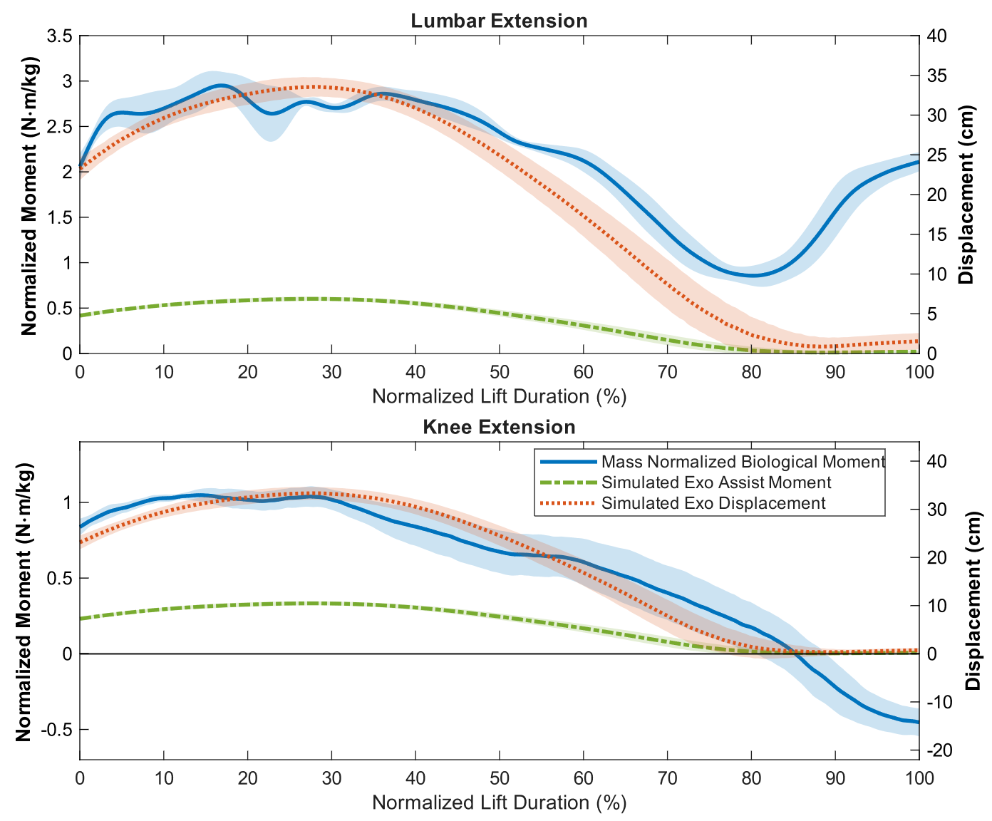
Where $F_{cable}$ represents total tension in the cable, $k_{exo}$ represents simulated stiffness, and $θ_{l}$, $θ_{h}$, and $θ_{k}$ represent the measured joint angles of the subject. $r_{l}$ and $l_{h}$ are anatomical lumbar and hip joint moment arms based on existing literature, with $r_{l}$ = 9 cm [40] and $r_{h}$ = 12 cm [41]. Moment arm of the knee $r_{k}$ is chosen to be 10 cm as it is a reasonable estimate of the distance between the knee rotation center and an offset rigid strut to carry the exo cable. The total exoskeleton assistance is then calculated by multiplying the shared cable force with individual joint moment arms. The assistance moment on the lumbar is doubled as one cable is used per knee with both crossing the lumbosacral joint. The simulation shows very strong correlation between both knee and back biological torque and displacement of the exoskeleton based on joint angles, in line with previous findings in literature showing the spring-like behavior of these joints during lifting tasks [12], [33]. The simulation also demonstrates that both knee and back joints share near identical peak biological torque locations at around 25% of the normalized lifting repetition, confirming that a single shared force profile can effectively assist both joints in lifting. The stiffness of the simulated exoskeleton was normalized by the mass of each subject and adjusted until the assistance profiles matched the output of existing single-joint devices. Simulated results from N=10 subjects using a normalized exo stiffness of 10.0 N/m∙kg achieved a total work reduction of 17.38 ± 3.54% for the lumbar and 36.39 ± 10.12% for the knee, aligned with existing back [8], [18] and knee [20], [42] devices mentioned in the previous chapter.
Figure 1. Simulated biological kinetic and kinematic trajectories alongside offloading assistance during a lifting task where a representative median subject lifts a 35lb kettlebell from the ground to waist height. (Left) Lumbar extension biological moment (solid blue line), simulated exoskeleton linear displacement (dotted red line), and simulated exoskeleton assistance moment (dash-dotted green line) across a single normalized lift duration. (Right) Right knee extension biological moment, composite band angle, and simulated exoskeleton assistance moment across the normalized lift cycle. Shaded bounds depict ± 1 standard deviation (SD) across 7 repetitions. Biological extension torques at both the lumbosacral and knee joints track closely with the total simulated exoskeleton displacement across all N=10 subjects simulated. total exoskeleton displacement is calculated using Equation (1) and exoskeleton assistance torque is calculated by scaling total displacement with linear stiffness. Simulated exoskeleton covers roughly ~20% of biological joint moment at the lumbar and ~30% joint moment at the knee.

Design Overview
The exoskeleton was designed based on the results of the biomechanical simulation with all functional components shown in Figure 2. The device connects the entire posterior chain of the wearer using four zero-stretch, low friction UHMWPE cables for each of its two independent parallel elements, fixed on one side to soft structures attached to the wearer’s body, and the other to either a passive or active assistive device. The cables travel from the wearer’s shoulder down to the knee joint, following the body’s natural contour at the back and trunk, and wrap around the thighs to the front of the patella (Figure 3). The UHMWPE cables are routed through PTFE tubes where they would otherwise be in direct contact with the wearer’s skin, with the material combination chosen due to their exceptionally low contact friction properties compared to alternatives such as Bowden cable [46], [47]. When tension is applied to either cable, the in-line force creates extension moments around the lumbar, hip, and knee joints simultaneously and assists the user in both descent and ascent during lifting.

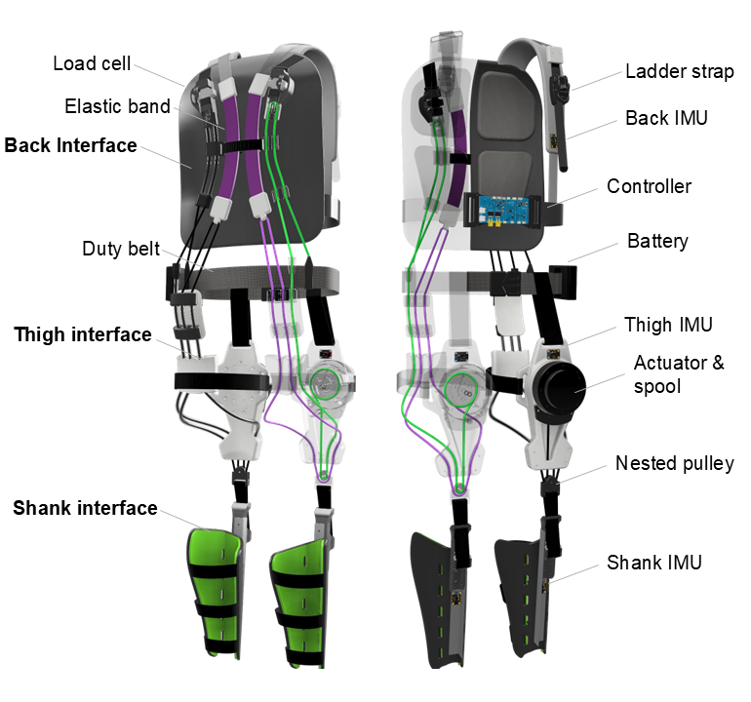
Functional Components
Figure 2. CAD renderings of the design show all major components of the device as well as both active (green) and passive (purple) cable paths of the right side of the exoskeleton through a transparent view.
The device is made up of three primary components at the shank, the thigh, and the back of the wearer. These components serve as interfaces between the functional structures of the exoskeleton and the user’s body as well as mounting points for the sensing and actuation layers of the active assistance elements of the device.

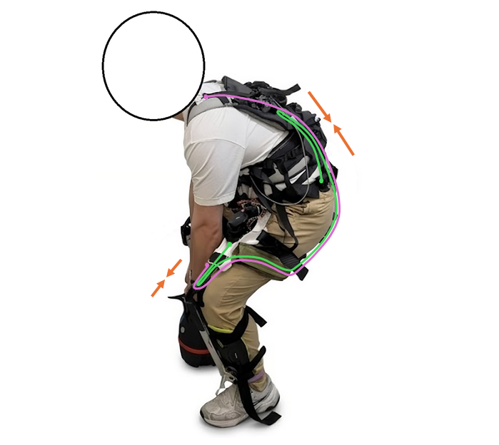
Back Component
Figure 3. Pilot wearing the exoskeleton while engaging in lifting, with cable paths highlighted on the left side.
The back component is built on a soft backpack frame base layer with adjustable shoulder and waist interfaces. Nylon webbing is used to fix two load cells, one at each shoulder, allowing for slight translational movements while immobilizing them from axial displacement caused by cable tension. These load cells measure in-line force of the active element which originates from the thigh down to the shank and back up. Instead of having active assistance directly terminate at the load cells, a single pulley is used to redirect the cables back down to the waist and fixed on the waist belt to double the torque created by cable tension on the lumbosacral joint, effectively reducing the required in-line force required to generate by the actuators. These cables are shrouded by PTFE tubing both before and after the loadcell pulley system to reduce both drag and wear of having the cord directly interface with the back of the backpack frame. In parallel with the active system are two elastic bands laid on the back of the frame, connected to the shoulder interface with adjustable ladder straps. These ladder straps can be manipulated by the user to tighten or relax the total length of the passive element which allows for on-the-fly passive element assistance profile adjustments including complete disengagement. The elastic bands are shrouded by accordion like covers made of thin nylon sheets, which expand and flatten when the bands stretch under tension. This allows the nylon material to slide relative to the backpack frame, significantly reducing friction by avoiding displacing rubber directly on fabric. The two passive bands are connected at the bottom with two UHMWPE cords, which travel down to the trunk along with the single cord from the active element.

Thigh Component
The thigh component is made up of two subassemblies located at the front and back of the leg. The rear subassembly consists of three PTFE tubes fixed with a 3D printed plastic guide at the base of the wearer’s trunk, which receives the three cables traveling down from the back component. These PTFE tubes are then routed to the side of the thigh, with one passive and one active cable traveling on the lateral side and the remaining passive cable traveling on the proximal side. These PTFE tubes are padded with soft foam on the wearer’s skin side which evenly distributes the compression forces generated by cable tension and reduces user discomfort. The three cables then combine at the subassembly at the front of the leg and further down to the knee joint. Along with the three cables is an additional active assistance cable originating from the front subassembly attached to the motor and spool. The actuation unit is uniquely placed at the front of the wearer’s thigh to create a double pulley at the knee joint, halving required cable tension to generate requisite joint torque. The actuator placement also minimizes energetic penalties from locomotion as they are heavy components placed close to the center of gravity. The actuator is placed with its output shaft facing towards the skin of the wearer, covering an enclosed cavity containing a 60 mm diameter spool which winds the cable and applies linear force when assistance is commanded.

Shank Component
The shank component is a hard structure that serves as the bottom terminating point of both active and passive elements. Being the only rigid component of the device that covers an entire body segment, the shank assembly is built on top of a hard plastic sports shin guard secured to the wearer using three adjustable fabric straps (Boa, Denver, CO, USA). An aluminum L channel strut is connected to the outside of the shin guard with large 3D printed plastic standoffs to form a ~10° angle with respect to the tibia and offsets the top of the strut away from the knee, forming a 10 cm moment arm in line with simulation. At the knee, the strut connects to a nested bearing mount through nylon webbing straps to allow for rotational and translational freedom. Finally, the bearing mount closes the loop for both the active and passive cable pairs. Because of the rigidity of the hard shin guard structure, the compressive force from cable tension can be evenly distributed around the shank. Additional padding is also applied on the inside of the shank interface to reduce pressure points at the top of the tibialis.

Design Summary
The three major components are structurally independent from one another and only connected by cables, allowing the exoskeleton to become completely transparent to the user when no assistance is applied. The only unifying anchor between components is a pair of pants modified to host Velcro interfaces on the lower body to fix both thigh and shank components to the body. A duty waist belt is used to prevent the heavy actuators from sliding downwards while simultaneously serving as a mounting interface for the active element central computing unit and the requisite 24V Li-ion battery. The total mass of the exoskeleton including battery is 4.8kg, which is comparable to many of the active single joint exoskeletons offering similar levels of activation on only one of the two joints assisted [26], [28], [36]. The lack of hard structures around joints and the presence of the passive element are two major factors contributing to the light-weight nature of this device.

Assistive Element Selection
The assistance magnitude target of the exoskeleton is a virtual mass-normalized stiffness of 10.0 N/m∙kg per side based on simulation results to enable spring like assistance scaled with posterior chain joint angles of the wearer. Total assistance is divided into a 60-40 split between active and passive elements respectively with the active element designed to be more powerful than passive to allow for more flexibility in assistance profiles.

Passive Element
The passive element uses two 25mm wide, 5mm thick rubber latex exercise bands placed at the back to store and release energy during lifting motion, with one band connected per leg. Two different passive band lengths were made to provide distinct stiffness based on the weight of the wearer similar to prior passive exoskeleton designs [13] with the heavy setting targeting wearers weighing 80 kg and the light setting targeting wearers weighing 65 kg. Appropriate lengths were found to be 8 inches and 9 inches for heavy and light settings respectively by characterizing stress-strain relationships of different lengths of bands on a universal testing machine (Instron, Norwood, MA, USA), linearizing the resulting profile, and choosing the closest match to linear stiffnesses of 320 N/m (4.0 N/m∙kg ∙ 80 kg) and 260 N/m (4.0 N/m∙kg ∙ 65 kg).

Active Element
The active element uses two AK80-6 (Tmotor with CubeMars drivers) robotic actuators attached to 60 mm diameter 3D printed spools fixed at the front of each of the two thigh components. The actuator and spool diameter are chosen based on the maximum speed and linear force requirements in the exoskeleton simulation scaled to a wearer weighing 100 kg. This is a major design challenge since unlike hinged designs where the actuator is rigidly coupled to the wearer’s body, the cable driven exoskeleton needs to actively track the user’s motion during the ascent phase of lifting which has the highest peak speed and torque demands during a complete lifting cycle. The AK80-6 is a unique fit among commonly used exoskeleton actuators due to its high continuous speed rating of 390 rotations per minute while retaining a rated torque of 12 Nm, with simulated results demonstrating that a single actuator can output up to 60% of biological torque requirements for the knee joint and 20% biological torque for the back joint (40% with one actuator on each side of assistance), which is well above the requisite 6.0 N/m∙kg virtual stiffness for active assistance to account for friction losses caused by cable displacement.

Sensors and Electronics
The active assistance of the exoskeleton is controlled by a low cost, 600MHz clock rate Teensy 4.0 microcontroller unit (MCU) attached to a custom printed circuit board (PCB) with embedded power distribution and communications interfaces to interact with remote sensors. Five MPU6050 (Adafruit, New York, NY, USA) inertial measurement units are placed above and below all relevant joints including the lumbar, hip, and knees, with one placed at the upper chest (referred to as the back IMU), one placed on each thigh, and one on each shank. Each IMU sends accelerometer and gyroscope data over three separate I2C high-speed+ buses to the MCU. A custom low level Kalman filter on the Teensy performs sensor fusion in real time to allow for computation of joint angles and velocities. Two MLP-200 load cells (Transducer Techniques, Temecula, CA, USA) with maximum force ratings of 890 N are mounted at the back to provide feedback for controlling exoskeleton assistance through in-line cable tension. Load cell signals are amplified by custom analog amplification circuitry on the PCB, converted by 16-bit analog to digital converters (ADC), and sent to the MCU through I2C lines shared with IMUs. The MCU uses Controller Area Network (CAN) protocol to send commands and receive telemetry data from AK80-6 actuators. The control loop is set to strictly execute at a frequency of 500 Hz, and all communications with peripheries, including both incoming and outgoing data packets, are conducted once per loop cycle. All electronics and actuators are powered by a single 24 V, 3 Ah Li-ion power-tool battery weighing 320 g. The low cost and power consumption of the central processor and sensor suite, combined with the flexibility of custom hardware and software, makes the unit a good candidate for future cable driven exoskeleton designs.

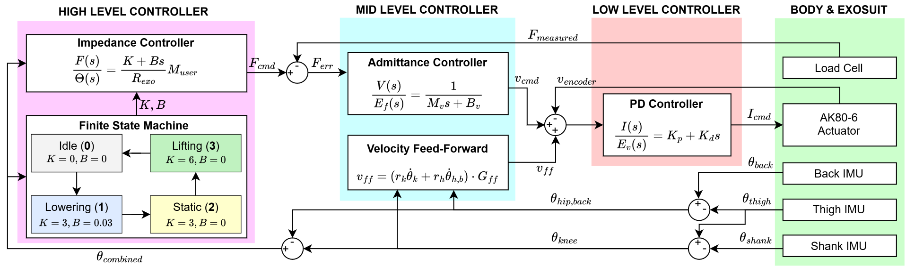
Closed Loop Controller
Figure 4. Block diagram of the exoskeleton’s active assistance controls. The finite state machine (FSM) determines stiffness (K) and damping coefficient (B) from joint kinematics and provides them to the impedance controller, which computes required linear force assistance in line scaled by subject mass and exo torque moment arm. The admittance controller computes the error between commanded and measured force from load cells to calculate required velocity command, assisted by the feed-forward controller to account for cable displacement from joint motion. The PD controller then uses encoder velocity feedback to command actuator torque to assist the wearer’s motion.
The closed-loop control system (Figure 4) employs a three-level control hierarchy to command active exoskeleton assistance based on wearer kinematics derived from IMUs. Joint angles are calculated using differential IMU pitch: knee angle ($θ_{\text{knee}}$) is defined as the pitch difference between thigh and shank IMUs, while combined hip-trunk angle ($θ_{\text{hip}}$) is derived from back and thigh IMUs. All joint angles are referenced to full extension ($0^{∘}$), with flexion defined in the positive direction.

High Level Controller
The high-level controller computes linear force commands ($F_{\text{cmd}}$) based on combined single-leg joint kinematics using an impedance controller governed by a four-state Finite State Machine (FSM). The impedance controller models a virtual spring ($K$) and damper ($B$) acting on the sum of measured knee and hip-trunk angles and velocities, with parameters dynamically updated by the FSM to match the stages of lifting. The FSM remains in an idle state with zero assistance ($K=0,B=0$) until combined flexion exceeds an initiation threshold. Upon entering the lowering state, partial stiffness and damping are applied to decelerate the wearer’s descent. When combined angular velocity drops below a stillness threshold, the FSM transitions to a static state, providing sustained extension torque during prolonged crouched postures. Finally, when joint extension velocities exceed a lifting threshold, the controller enters the lifting state to supply the maximum $6.0\text{ N}⋅\text{m/kg}$ virtual stiffness scaled by user body mass to offload joint extensors during ascent before returning to idle. Transition thresholds were initially set through pilot testing and tuned during deployment to accommodate subject-specific lifting mechanics. The large discontinuity in assistance magnitude between static and lifting stages is present due to prior studies [12], [48] demonstrating heavy user preference for sudden power injection during ascent, as well as reducing knee and hip flexor co-activation by avoiding overly stiff extension assistance in descent [20].

Mid And Low-Level Controller
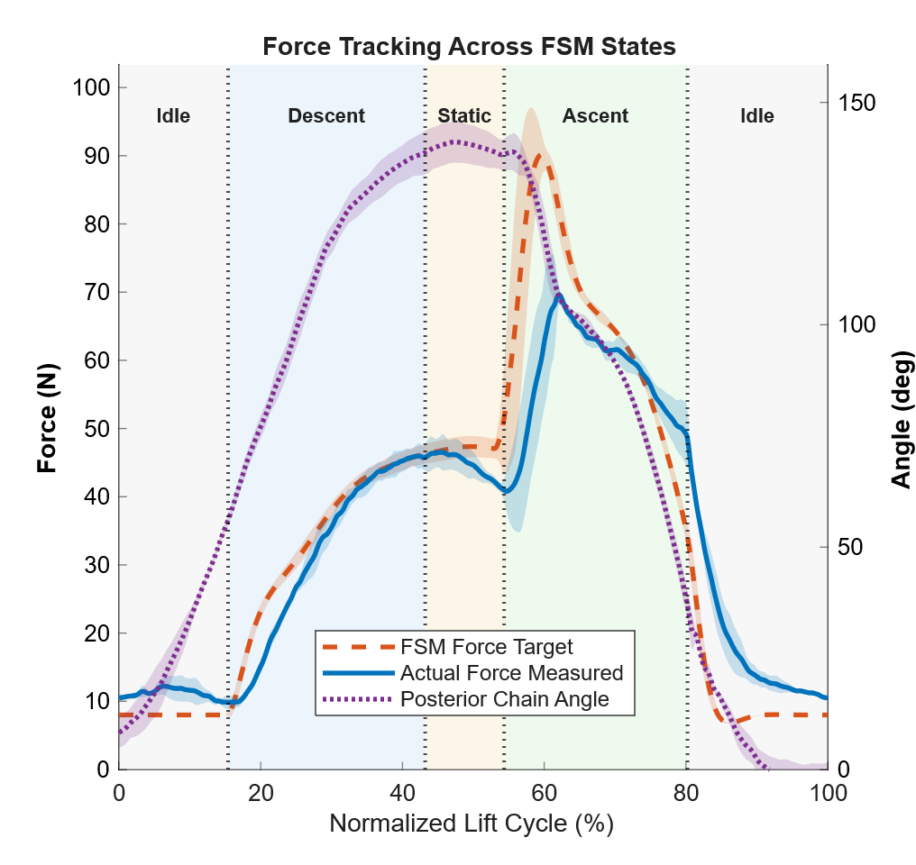
The mid-level controller converts incoming force commands ($F_{\text{cmd}}$) into actuator velocity references ($v_{\text{cmd}}$) using a parallel admittance and feedforward controller. The admittance controller simulates a linear system with virtual mass $M_{v}$ and virtual damping $B_{v}$, mapping force error ($F_{\text{err}}=F_{\text{cmd}}-F_{\text{meas}}$) to a target actuation velocity ($v_{\text{adm}}$) to render a low-impedance interface and prevent cable slack during movement. The velocity feedforward component operating in parallel scales measured joint velocities by their corresponding kinematic moment arms, adjusted by a subject-specific gain ($G_{\text{ff}}$) to account for suit individual wearer size. This feedforward pathway decreases system latency and enables the actuators to track joint motion without requiring a force error to be present, ensuring exoskeleton transparency during unassisted movement while enforcing a minimum inline force of 8 N to prevent cable slack. The velocity command is then converted to motor current by a simple PD controller using encoder velocity feedback.
Figure 5. Cable tension tracking and combined joint kinematics across dynamic finite state machine (FSM) control states during a representative lifting task with maximum force normalized RMSE of 10.22%. (Left Y-Axis) Target commanded force (dashed orange line), right-side measured force (solid blue line), and left-side measured force (dash-dotted green line) averaged across valid lift cycles. (Right Y-Axis) Right-side combined joint angle (dotted purple line). Background shaded regions and vertical dotted boundary lines denote dynamic average FSM state transitions: Idle / State 0, Descent / State 1, Static Hold / State 2, and Ascent / State 3. Shaded envelope bounds represent ±1"SD across repeated trial cycles.

Cable Force Tracking
Maintaining precise force tracking in cable-driven exoskeletons is inherently difficult due to load-dependent transmission losses and non-linearities [46]. This is especially challenging for this device where the cable is routed through the entire posterior chain through compliant interfaces with multiple points of deflection. To ensure proper cable tracking, load cell data was collected from N = 7 pilots performing three repetitions of simple lifting motion and root mean square tracking error (RMSE) was calculated and normalized as a % of maximum force. The force tracking profile of a representative subject is visualized in Figure 5. The average normalized RMSE is found to be 11.03% ± 2.11% (standard deviation).

Human Subject Testing

Experimental Protocol
11 healthy adults (9 male, 2 female, age 25 ± 2.56 years old, height 175.0 ± 4.84 cm, weight 76.2 ± 8.86 kg) participated in this study. All participants provided written informed consent before taking part in the experiment. The study was approved by the Georgia Institute of Technology’s Institute Review Board (H21228). In order to measure the effects of the exoskeleton on the wearer’s total energy cost and muscle activations during repeated lifting, each participant was asked to perform two types of lifting tasks with three different exoskeleton conditions: exoskeleton disengaged and unpowered; passive assistance only; and combined active-passive assistance.
The primary lifting task required the participant to lift a 35lb kettlebell (25lb for participants weighing under 70kg) from waist height (an elevated platform 65 cm from ground level for all participants) to ground level with the weight placed directly in front of the participant, who then returns the weight to waist height for a complete rep (Figure 6). The weight and height were chosen to match existing literature that required lifters to simulate symmetric manual labor movement patterns. The secondary lifting task required the participant to move the kettlebell from waist height directly in front to a position 90° to the right of the lifter at ground level (Figure 7). This task introduces a rotation requirement on both the ascent and descent stages of the movement and simulates asymmetric lifting tasks studied by previous literature [22], [29].
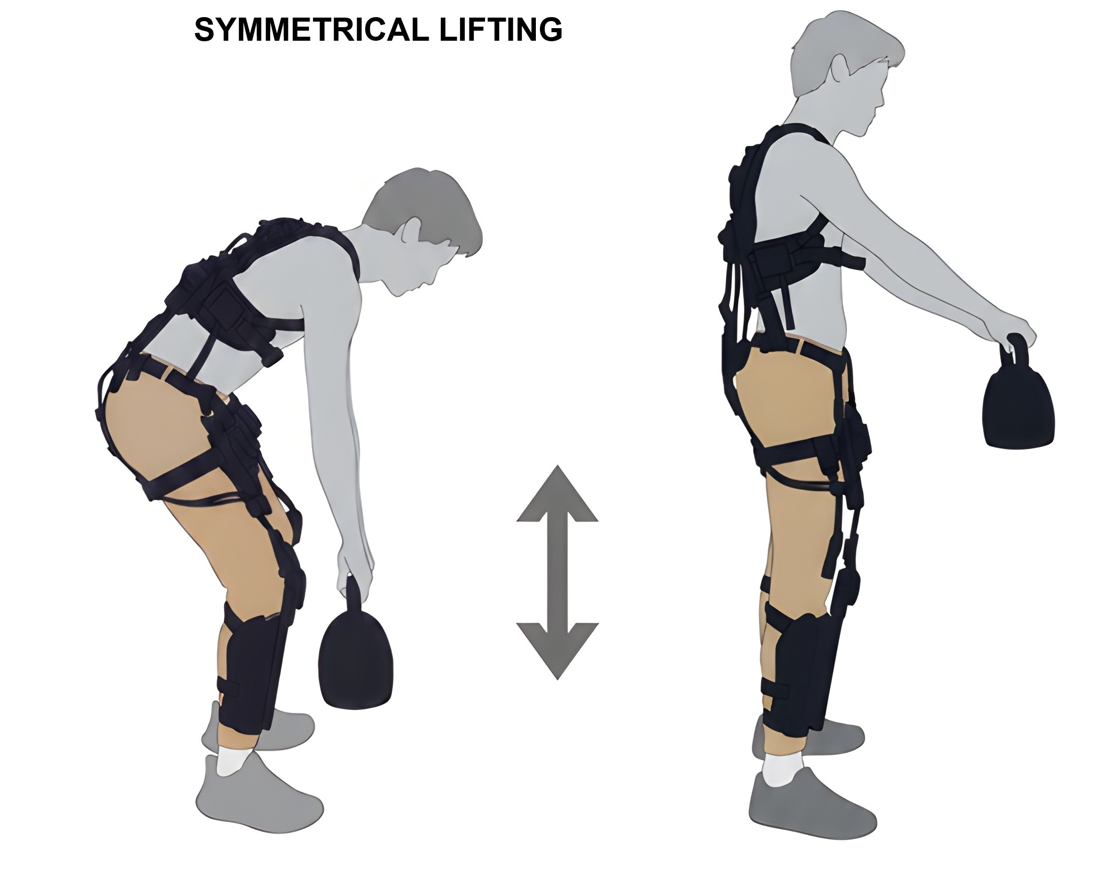
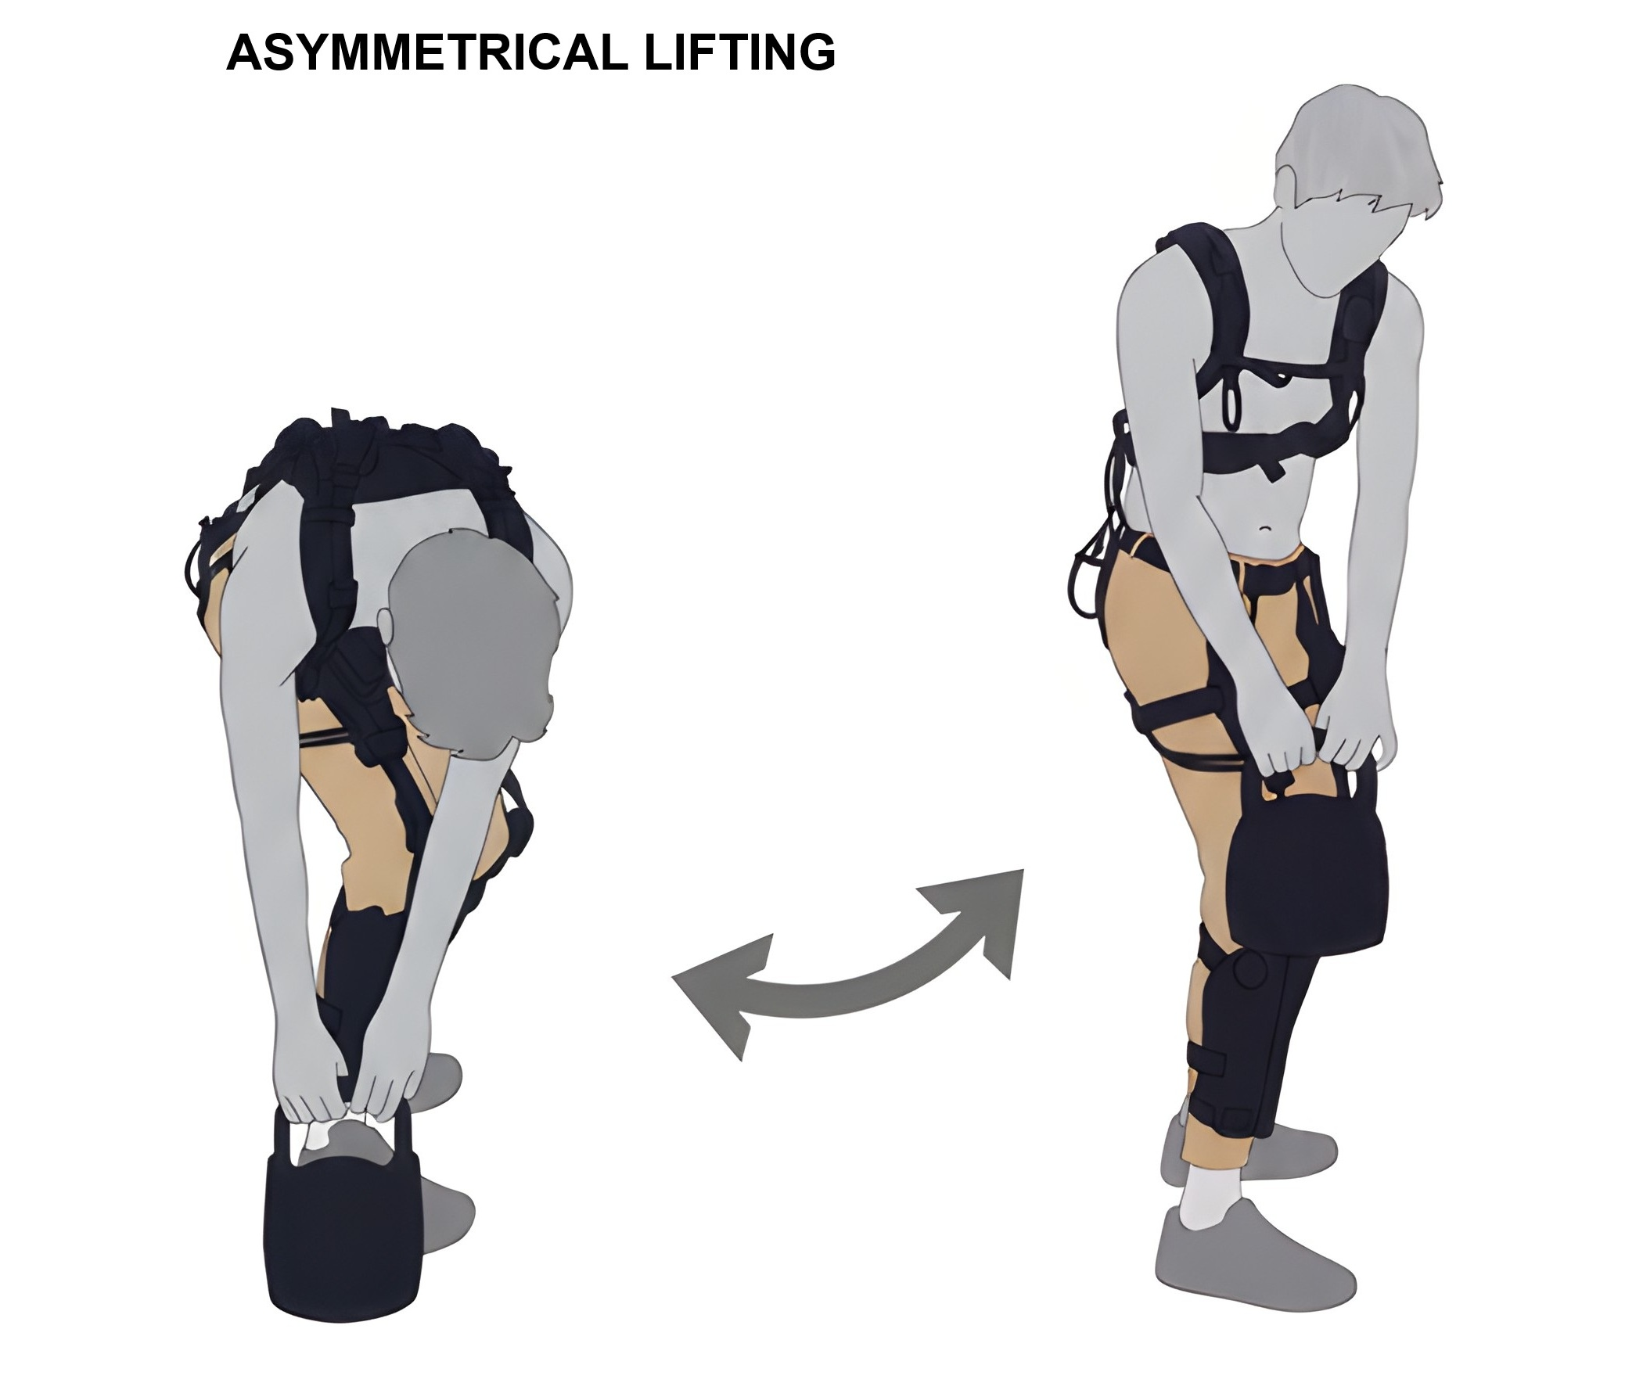
Each human subject was asked to participate in a single combined session with all conditions and tasks and all measured outcomes, including metabolic cost, muscle EMG activations, and self-reported effort and preference measurements. The participant is first fitted with the exoskeleton, which begins with the researcher adjusting the passive component to be without slack when the subject is standing up right to ensure consistent passive element engagement between subjects. Then, the active component is tuned by scaling a percent assistance gain no less than 20% and no more than 30% of estimated biological torque from subject weight based on the participant’s verbal feedback on comfort level and perceived assistance. The participant is then asked to perform three repetitions of both symmetric and asymmetric lifting while load cell force measurements are recorded to characterize the force tracking of the exoskeleton.
Figure 6 Graphic representation of the symmetric lifting tasks performed during this study. Each repletion begins with the 35lb kettlebell (25lb for subjects below 70kg) placed on an elevated platform at waist level, followed by the participant lowering the weight down to ground level directly in front of their feet, releasing their hands for a brief moment, and returning the weight to the elevated platform.
Figure 7. Graphic representation of the asymmetric lifting tasks performed during this study. The start of the motion is identical to symmetrical lifting, but when the participant lowers the weight, they are asked to place the weight at the ground level directly to the right of their right foot. This introduces a twisting element to the motion and is a type of lifting commonly observed in the workplace.
After tuning and fitting are completed, participants were asked to perform six total sets of symmetrical lifting while wearing a metabolic measurement system (K5, COSMED, Rome, Italy), repeating each exoskeleton condition in twice using a double-reversal experimental design (A-B-C-C-B-A) to mitigate cumulative fatigue and metabolic drift according to established protocols [49], [50] Each set required the participant to complete 50 repetitions in 10-second fixed intervals cued by a metronome for a total of five minutes per set, with a five-minute minimum resting period between each set. Participants were then asked to perform three additional sets of asymmetric lifting (one set per exo condition in random order) on the right side only with 20 reps per set without metabolic measurement to minimize dropouts caused by fatigue. Immediately after each set, the participant was asked to rate their perceived effort based on the Borg Rating of Perceived Exertion (RPE) which ranges from 6 (very, very light) to 20 (very, very hard) [51]. For conditions other than exo unpowered, participants were also asked to rate the felt assistance between -5 (very unhelpful) to +5 (very helpful) with 0 representing no felt assistance. Muscle activation was recorded using surface EMG sensors (Co-apt, Chicago, IL, USA) for the following seven muscles for all sets: vastus medialus (VM), rectus femoris (RF), vastus lateralis (VL), biceps femoris (BF), semitendinosus (ST), left erector spinae (ES-L), and right erector spinae (ES-R). The seven muscles selected are the primary extenders of the knee, hip, and lumbosacral joints during lifting. EMG sensors were placed based on SIENEM guidelines [52] with maximum voluntary contraction of each muscle collected a priori. Due to sensor availability, quadriceps and hamstring EMGs were only placed on the right leg.
Due to the highly strenuous nature of the protocol, not every participant was able to complete all required sets for every condition and lifting type. Only six out of 11 subjects completed all symmetric and asymmetric sets, while five only performed symmetric lifting. For symmetric lifting, nine out of 11 subjects performed the experiment with metabolic measurements while two wore EMGs only, allowing them to complete only one set per exoskeleton condition to manage fatigue. Three participants took part in a separate collection set where the exoskeleton unpowered condition was directly compared with the no-exoskeleton condition, where subjects performed the same symmetrical lifting set without wearing the exoskeleton to study the impact of exoskeleton weight on metabolic cost. The participants in this collection performed four total sets (A-B-B-A) with the no-exo and exo-unpowered conditions while wearing the metabolic system.

Data Analysis
The metabolic cost (W/kg) of each exoskeleton condition during symmetrical lifting was calculated from oxygen and carbon dioxide volumetric flow rates (${\dot{V}}_{O_{2}}$ and ${\dot{V}}_{{CO}_{2}}$) in the subject’s exhalation breath measured by the K5 metabolic system. Volumetric flow rates collected in the last two minutes of each trail were averaged to compute representative steady state raw metabolic readings. For subjects that were unable to complete the full five-minute trial, measured flow rates were fitted using a first order exponential decay function to obtain steady state values. The Brockway equation (2) [53] was used to convert raw metabolic measurements to energy expenditure:
 | $$EE=16.58∙{\dot{V}}_{O_{2}}+4.51∙{\dot{V}}_{{CO}_{2}}$$ | (2)
Where EE represents energy expenditure in Watts. The energy expenditure is then normalized by weight for each subject and averaged across the two trials of each condition to generate a single metabolic cost value per exo condition and subject.
Both total and peak muscle activations were calculated using surface EMG measurements taken during the lifting for both symmetric and asymmetric tasks. Raw surface EMG signals were first band-pass filtered between 20 Hz and 400 Hz using a zero-phase minimum-order infinite impulse response (IIR) Butterworth filter to eliminate high frequency noise and motion artifacts, full wave rectified, and low-pass filtered using a zero-lag 5th-order Butterworth filter with an effective order of 10 and a cutoff frequency of 5Hz to construct linear envelopes. The filtered signal is then normalized as a percentage of the measured maximum voluntary contraction (% MVC) of each muscle to enable inter-muscle and inter-subject comparisons and divided into individual repetitions using 10 second fixed intervals. Finally, both integral ($\text{\% MVC}⋅\text{s}$) and peak (% MVC) EMG activation magnitudes are computed for each repetition and averaged into single representative values per muscle. For symmetrical lifting tasks, only the last 20 out of 50 total repetitions of each condition are averaged, and first 30 repetitions of the trial are treated as an extended acclimation period for the subject to adapt their movement pattern and activation to the assistance profile provided. For the same reason, the first symmetric lifting trial of every condition is not used for EMG calculation to avoid penalizing exo conditions from lack of proper familiarization since participants had very little acclimation time before the first trail to minimize fatigue. For asymmetric tasks, the last 15 out of 20 total repetitions are averaged since only one trail of each condition is taken, and asymmetric tasks are always performed after symmetric tasks.
Both perceived exertion and exo helpfulness ratings for symmetrical lifting are averaged across two trials of the same condition for all experiments conducted with double reversal to minimize fatigue induced bias in addition to having conditions orders randomized for every subject. Asymmetric tasks without double reversal relies solely on condition randomization to minimize this bias.

Statistical Analysis
To evaluate the effect of the exoskeleton assistance conditions (exo unpowered, passive assistance, and hybrid assistance) across participants, a one-way Repeated Measures Analysis of Variance (RM-ANOVA) was executed for every outcome metric including weight-normalized energy expenditure (W/kg), peak EMG activation ($\text{\%MVC}$), integral EMG activation ($\text{\% MVC}⋅\text{s}$), Borg RPE (rating from 6 to 20), and exo helpfulness (rating from -5 to +5). When a significant main effect was detected ($α=0.05$), pairwise post-hoc comparisons were performed using Bonferroni corrections to adjust for multiple comparisons and control the family-wise Type I error rate. Statistical significance was defined as $p<0.05$. Effect sizes were quantified using partial eta squared ($η_{p}^{2}$) for all ANOVA main effects, and within-subject Cohen's $d_{z}$ was calculated for pairwise post-hoc comparisons to quantify the magnitude of differences between conditions regardless of statistical significance. Descriptive statistics are reported as mean $±$ standard deviation ($\text{SD}$). All statistical analyses were conducted using MATLAB r2025a (MathWorks, Natick, MA, USA).

Results

Metabolic Cost
A one-way repeated measures ANOVA revealed a statistically significant main effect of exoskeleton assistance condition on net steady-state metabolic power ($F\left(2,16\right)=10.59$, $p=0.0012$). Mean metabolic power decreased from $5.58±0.97\text{ W/kg}$ in the No-Exo condition to $5.36±0.82\text{ W/kg}$ in the Passive condition and further decreased to $5.05±1.03\text{ W/kg}$ in the Hybrid condition (Figure 8). Bonferroni-corrected post-hoc pairwise comparisons indicated that the Hybrid active-passive exoskeleton achieved significant metabolic savings of 9.48% compared to the exo unpowered baseline ($p=0.0109, { d}_{z}=1.353$) and 5.77% compared to passive only assistance ($p=0.0360, d_{z}=1.353$). Although passive assistance alone produced a $3.94\%$ reduction compared to the No-Exo baseline ($d_{z}=0.621$), this pairwise difference did not reach statistical significance after Bonferroni correction ($p=0.2978$).

Electromyography
Figure 8 . Net steady-state metabolic power ${\text{W}}_{ss}$) across experimental conditions: Exo unpowered (baseline), passive assistance, and hybrid (Active-Passive) assistance (N = 9). Bars depict group means, error bars denote ±1 SE, and individual trajectories across subjects are shown by colored connected markers. Percent reductions are reported relative to the exo unpowered baseline condition. Statistical significance from Bonferroni-corrected post-hoc pairwise comparisons are indicated by brackets (${}_{​}^{*}p<0.05$, $n.s.=\text{not significant}$). The red dotted line indicates the no-exo baseline metabolic cost, where a separate comparison between no-exo and exo-unpowered found a 1.8% difference in metabolic cost with N = 3 subjects.
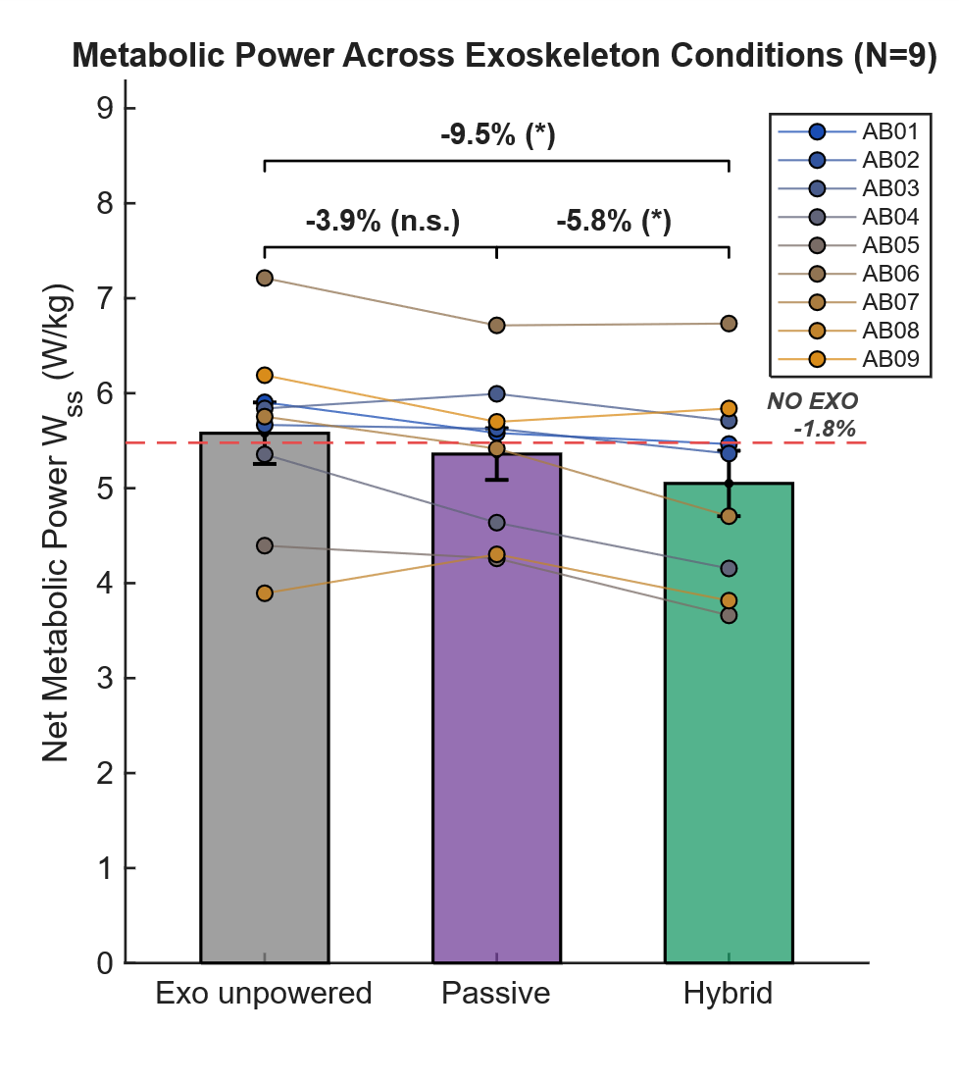
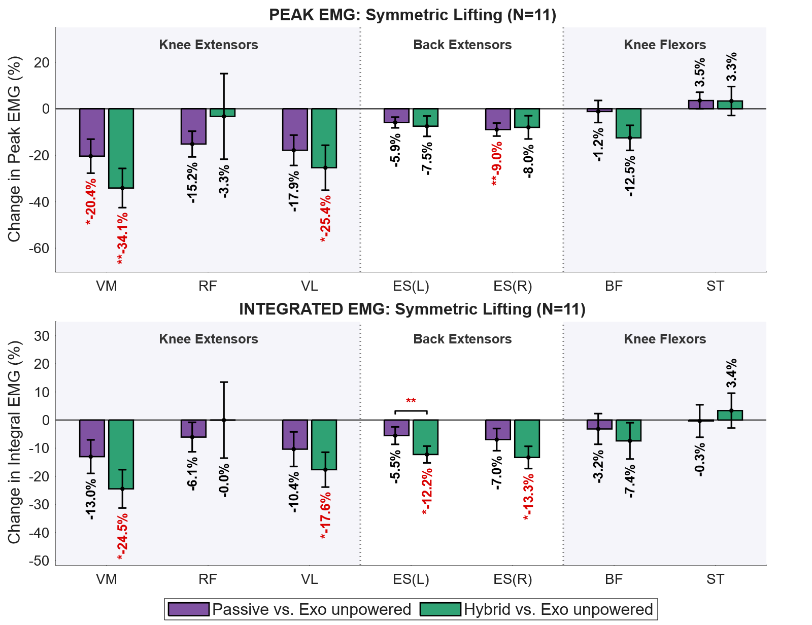
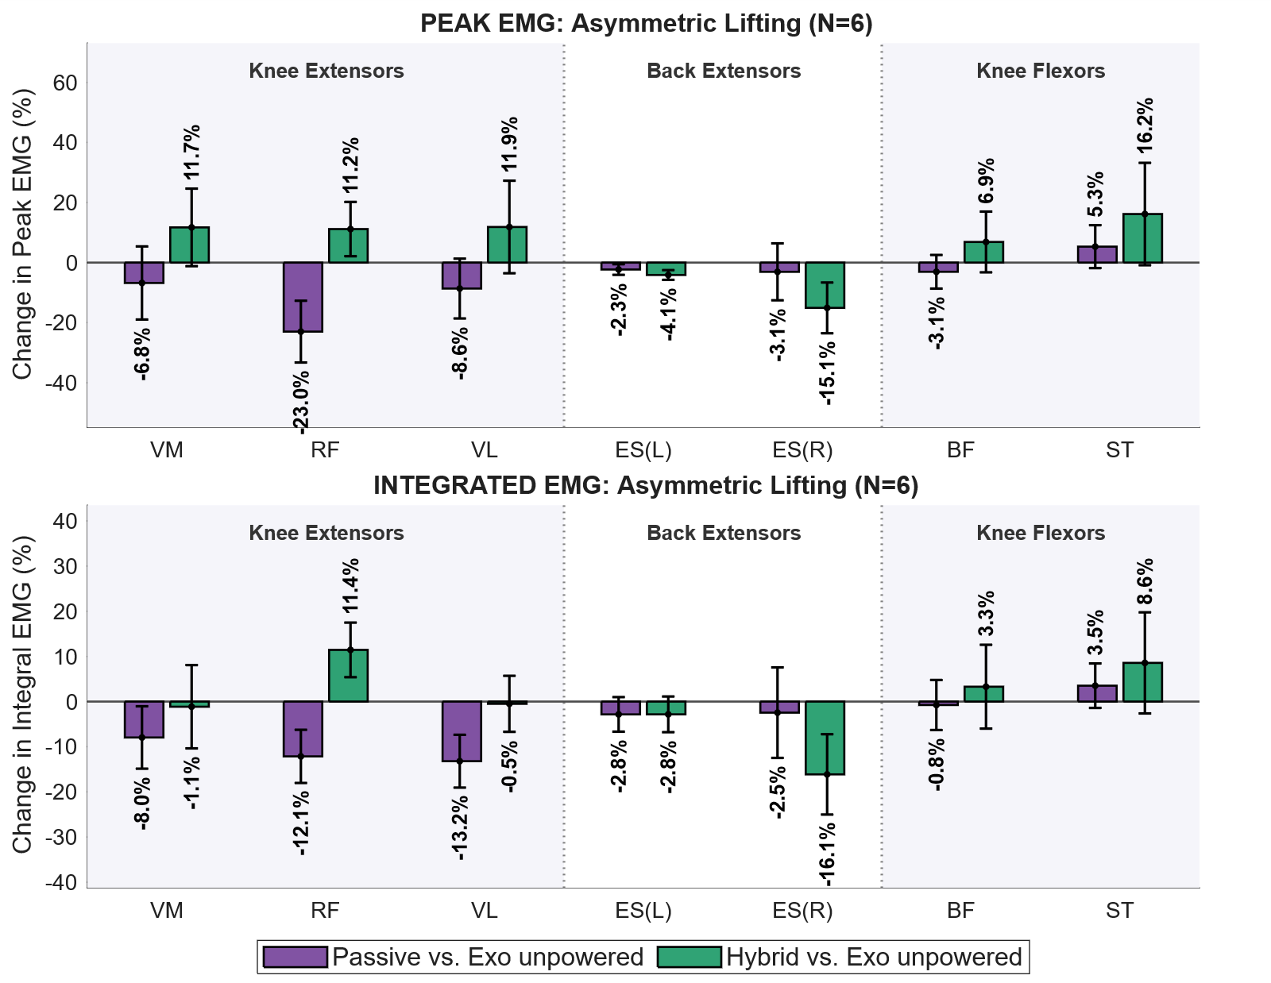
During symmetrical lifting tasks, exoskeleton assistance yielded significant reductions in peak and integral muscular activation within the primary target knee and back extensors, while non-target knee flexors remained largely unaffected (Figure 9). One-way repeated-measures ANOVAs revealed statistically significant main effects of assistance condition for the vastus medialis, vastus lateralis, and both left and right erector spinae, all exhibiting large main effect sizes. Bonferroni-corrected post-hoc pairwise comparisons demonstrated that the hybrid active-passive condition provided the highest level of offloading: both vastus medialis and vastus lateralis were shown to have significantly lower peak (~ -30%) and integral (~ -25%) activation compared to baseline, and both left and right erector spinae muscles showed significantly reduced integral activation (~ -13%). Although passive assistance only caused significant peak integral activation in the right erector spinae, all knee and back extensors trended towards decrease with medium to large effect sizes. The only major extensor probed that did not show significant change from baseline in any condition is the rectus femoris. Measured knee flexors in the hamstring muscles also showed no clear evidence of positive or negative effect from exoskeleton assistance.
Figure 9. Relative changes in Peak and Integrated EMG across 7 muscles during symmetric lifting under passive and hybrid exoskeleton assistance. (Top) Percentage change in Peak EMG relative to the unpowered exoskeleton baseline during symmetric lifting ($N=11$). (Bottom) Percentage change in Integrated EMG (iEMG) relative to unpowered baseline during symmetric lifting ($N=11$). Muscles are categorized into three functional anatomical regions: Knee Extensors (VM: Vastus Medialis, RF: Rectus Femoris, VL: Vastus Lateralis), Back Extensors (ES(L): Left Erector Spinae, ES(R): Right Erector Spinae), and Knee Flexors (BF: Biceps Femoris, ST: Semitendinosus). Bars represent group mean percentage changes ($±\text{SE}$) for Passive assistance (purple) and Hybrid assistance (green) relative to Exo unpowered ($0\%$ baseline). Statistically significant reductions relative to unpowered baseline are highlighted in bold red with leading asterisks (${}_{​}^{*}p<0.05$, ${}_{​}^{**}p<0.01$, ${}_{​}^{***}p<0.001$; repeated-measures ANOVA with Bonferroni post-hoc adjustment). Overhead brackets indicate significant pairwise differences directly comparing Passive and Hybrid assistance conditions.
Figure 10. Relative changes in Peak and Integrated EMG across 7 muscles during symmetric lifting under passive and hybrid exoskeleton assistance. (Top) Percentage change in Peak EMG relative to the unpowered exoskeleton baseline during symmetric lifting ($N=6$). (Bottom) Percentage change in Integrated EMG (iEMG) relative to unpowered baseline during symmetric lifting ($N=6$).
EMG activation measurements in different exo conditions for asymmetrical lifting (Figure 10) tasks did not yield reductions comparable to symmetric lifting tasks. Analysis of muscle activation patterns revealed no statistically significant main effects of exoskeleton assistance across any of the seven monitored muscles and exoskeleton conditions, likely due to a lower sample size and higher result variations between subjects. Notably, the passive assistance condition reduced quadriceps activations with large effect sizes but did not positively impact hip or back extensors, why the hybrid assistance condition lowered proximal side erector spinae activation at the cost of increasing quadriceps activity.

Subject Reported Metrics
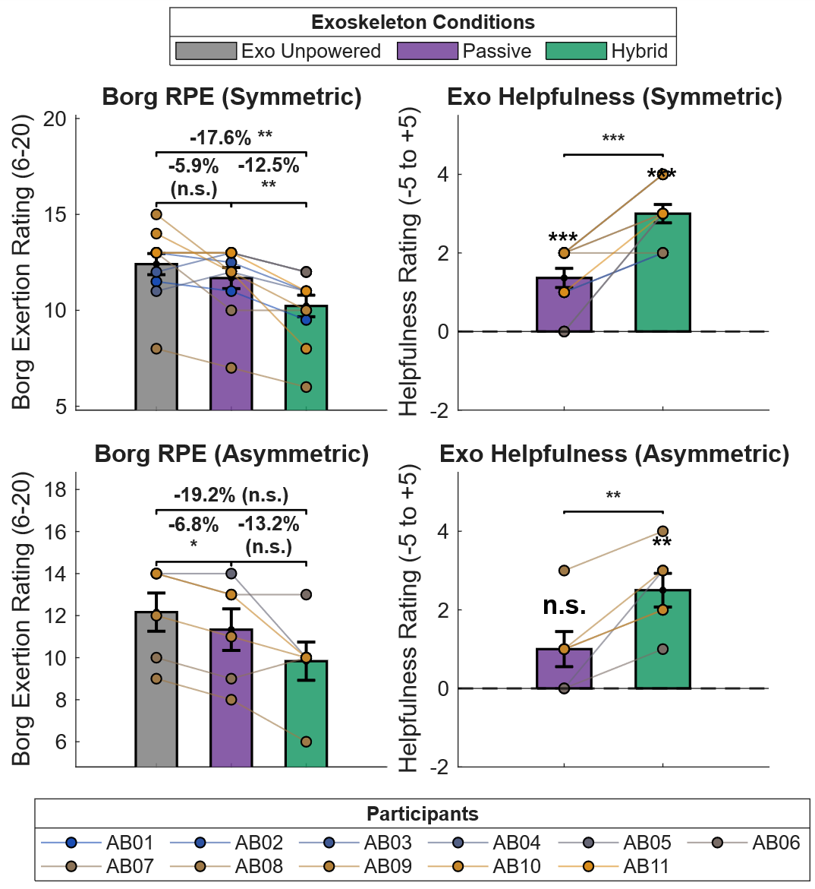
Exoskeleton assistance significantly influenced both participants' ratings of perceived exertion (Borg RPE) and exo helpfulness during both symmetric and asymmetric lifting (Figure 11). A one-way repeated measures ANOVA revealed a significant main effect of assistance condition on Borg RPE for symmetric lifting ($F\left(2,20\right)=12.43$, $p=0.0003$). Post-hoc pairwise comparisons with Bonferroni adjustments indicated that while the Passive condition yielded a small reduction in perceived exertion relative to the No-Exo baseline, this decrease was not statistically significant (5.9% reduction, $p=0.349$, $d_{z}=0.518$). In contrast, the Hybrid active-passive mode significantly reduced exertion compared to both the No-Exo baseline ($17.6\%$ reduction, $p=0.010$, $d_{z}=1.156$) and the Passive condition ($p=0.002$, $d_{z}=1.438$). Consistent with perceived exertion outcomes, exoskeleton helpfulness ratings varied significantly across conditions ($F\left(2,20\right)=70.60$, $p<0.0001$). Both active and passive assistance were rated as significantly more helpful than the unpowered baseline. The Passive condition provided a baseline level of perceived assistance compared to exo unpowered ($p=0.001$), but the Hybrid condition was rated as significantly more helpful overall, outperforming both the unpowered baseline ($p<0.0001$) and the Passive-only assistance mode ($p=0.0005$).
Figure 11. Subjective ratings of perceived exertion and exoskeleton helpfulness across lifting asymmetry protocols ($N=11$ for symmetric lifting, $N=6$ for asymmetric lifting). (Top Left) Borg Rating of Perceived Exertion (RPE, 6–20 scale) during symmetric lifting across Exo Unpowered, Passive, and Hybrid conditions. (Top Right) Exoskeleton helpfulness ratings (-5 to +5 scale) relative to unpowered baseline ($0$) during symmetric lifting. (Bottom Left) Borg RPE during asymmetric lifting across assistance conditions. (Bottom Right) Exoskeleton helpfulness ratings during asymmetric lifting. Bars depict group means, error bars denote $±1\text{ SE}$, and colored connected markers trace individual subject trajectories across conditions.
Despite mixed results in EMG activation, subjective outcome metrics for asymmetric lifting yielded very similar trends compared to symmetrical tasks. During asymmetric lifting, exoskeleton assistance significantly reduced perceived exertion ($F\left(2,10\right)=7.95$, $p=0.0086$). The Passive condition significantly lowered exertion by $6.8\%$ compared to the unpowered baseline ($p=0.012$, $d_{z}=2.041$), whereas the Hybrid condition yielded a $19.2\%$ reduction but missed statistical significance ($p=0.052$, $d_{z}=1.429$). Exo helpfulness ratings also varied significantly across conditions ($F\left(2,10\right)=19.00$, $p=0.0004$, $η_{p}^{2}=0.792$). The Hybrid active-passive system was rated significantly more helpful than both the baseline ($p=0.006$) and the Passive mode ($p=0.021$), while the Passive mode did not differ significantly from baseline ($p=0.227$).

No Exo Comparison
A separate N = 3 study conducted to compare the exo unpowered condition to the no-exo baseline showed no significant difference between the two conditions (Figure 12), with the exo unpowered condition incurring an additional 1.8% of steady state energy expenditure during repeated lifting. This figure is comparable to the measured uncertainty of the COSMED K5 system of ±1.34% [54].
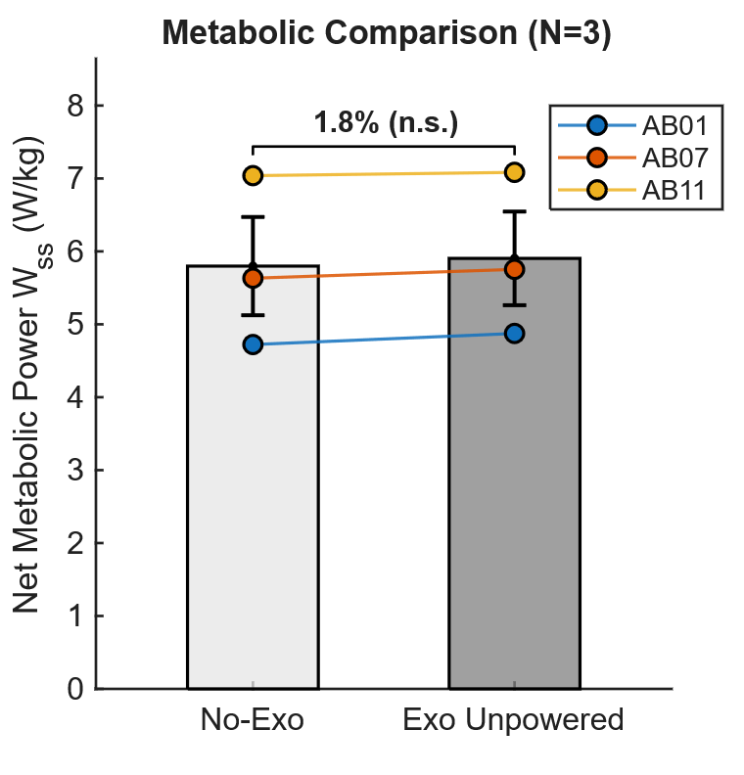
Figure 12. Comparison of net steady-state metabolic power ($W_{\text{ss}}$) between the unassisted baseline (No-Exo) and unpowered exoskeleton (Exo Unpowered) conditions ($N=3$). Solid bar heights and error bars denote the group mean and $±1\text{ SE}$, respectively. Individual subject trajectories are represented by colored line traces (AB01, AB07, AB11).

Discussion

Study Summary
In this study, we presented the design of a hybrid assistance underactuated knee-back exoskeleton to assist in occupational lifting activities. The exoskeleton uses two independent assistive elements in parallel to reduce total body energy expenditure and muscular effort of both knee and back extensors. The light weight and hinge-free design allow the device to be highly transparent to the user when not providing assistive torque, with the comparison between no-exo and exo unpowered conditions showing minimal difference in total body energetics during lifting.

Highlight Results
A key finding in this study is that the underactuated hybrid assistance profile simultaneously reduced knee extensor activation, back extensor activation, energy expenditure, and perceived exertion during repeated symmetrical lifting, which is unique for this type of device in the literature. All nine participants in the study who completed the metabolic experiment experienced a decrease in energy expenditure with hybrid assistance compared to the exo unpowered condition, with the average reduction of 9.5% comparable to existing active assistance knee exoskeletons [12], [28]. This is one of the major advantages of having the knee as part of the assisted joints as the quadriceps are major muscle groups responsible for a large percentage of total body energy consumption, as opposed to back extensors which are relatively small [55].

Symmetrical Lifting
EMG analysis also indicated that both assisted joints experienced significant reduction in activation during repeated symmetrical lifting with reduction magnitudes in line with both simulated results and existing devices. The simultaneous reduction of both muscle groups indicates that on average, users of the device did not offload effort from one muscle group to the other. In addition, no significant change in activation was found in antagonistic knee flexors. This demonstrates a major advantage for hinge free systems as they do not distort the user’s natural kinematics with hard structures around joints and incentivize compensatory movements or overactivations. Out of all extensors measured during symmetrical lifting, the only muscle that did not experience significant reduction was the rectus femoris. In fact, in some subjects, rectus femoris activation increased by up to 30% while activation of the vastus heads decreased. This is likely because the rectus femoris is a bi-articular muscle that acts as both a knee extensor and hip flexor. During lifting, both knee and hip joints simultaneously flex, which leads to significantly lower activation of the rectus femoris compared to the vastus heads [56]. Therefore, for studies aiming to reduce total knee activation during squatting like tasks, a change in RF activation is not a strong predictor of likelihood of knee injury from exertion.
Although the device caused significant reduction in total back extensor activation, no significance was found for reduction in peak activation magnitude. A likely cause of this is the error in force tracking when the finite state machine transitions from static to ascent as shown in Figure 1. When the large force discontinuity is commanded, the actuator cannot provide the required in-line tension due to frictional losses in the line, which suppresses the intensity of the peak assistance provided to lumbar extension and flattens the assistance profile. This inability to reach peak torque is not a major problem for knee assistance because the origin of active assistance is at the thigh, directly adjacent to the knee joint with minimal friction losses in-between. The mean normalized RMS tracking error of 11% of the device is comparable to the only other underactuated knee exoskeleton in the literature tracking this metric [38] while providing significantly greater torque assistance, but most single joint assistance cable driven exoskeletons track peak torque better [29], [57] with RMSE around 1-3%.

Asymmetric Lifting
Compared to symmetrical lifting, the asymmetric task did not produce significant change in any of the muscles measured, and only general trends can be observed. The passive element appears to slightly decrease knee extensor activation while having no effect on back extensors, while the active element caused a decrease in right erector spinae at the cost of slightly increased knee extensor activation. This inconsistent behavior can largely be attributed to the exoskeleton heavily distorting lifting motion during the asymmetric task. Unlike symmetrical lifting where the exoskeleton does not interfere with the user’s natural motion, asymmetric lifting requires the participant to move the weight horizontally across the lower body, where the hard structure of the shank interface becomes an obstacle. Most participants began to extend the kettlebell away from their center of gravity when wearing the exoskeleton which drastically increases back extensor activation [58]. In addition, participants were asked to keep both feet in contact with the ground to ensure consistency and to align with prior studies using this movement [22], [29] which lead to awkward and unnatural compensation strategies. Most subjects chose not to bend their knees at all during the motion and used only their back to move the weight, leading to minimal activation of all knee extensors measured. Overall, it was found that this exoskeleton is not effective at reducing risk of injury to the lumbar during asymmetrical lifting, despite participants rating the assistance as significantly more helpful than baseline likely due to the strong power injection from the state machine transition.

Design Limitations
Although the design of the device is created to serve as proof of concept for future underactuated lifting exoskeletons, there are some limitations that should be noted as possible areas of improvement. While our device demonstrated the viability of applying large torque magnitudes to the knee without a rigid hinge, it did not address the issue of increased shear loading on the knee joint which can lead to an elevated risk of injury. Prior studies have shown that joint contact forces can be calculated through EMG activation of proximal muscle groups and inverse kinematics using motion capture [59], which can be an interesting future avenue of exploration with this exoskeleton to compare positive effects of tensile force reduction and deleterious effects of shear force increase when this type of soft assistance is applied. Another major limitation of the exoskeleton is the previously discussed issue with force tracking during peak commanded assistance. The cable of the exoskeleton spans more than 1.5 m on the wearer and experiences significant contact friction losses despite the slickness of the materials used. Future designs can investigate the possibility of implementing highly aggressive admittance controller gains to command large motor velocity when at the peak assistance is required, while still maintaining the stability of the controller during all other states.

Study Limitations
Outside of design limitations, there are experimental limitations within this study that should be considered for future investigations. Primarily, this study only required the user to perform repeated stationary lifting which is not entirely representative of occupational lifting activities. Studies have found that when lifting assistance exoskeletons are applied in practical manual labor conditions, the muscular effort and energy expenditure reduction can be drastically reduced [19] due to the large amount of ambulation compared to pure lifting. Since this exoskeleton is hingeless and can provide both knee and back assistance, deploying this device in a circuit activity where a variety of lifting tasks is mixed with ambulatory tasks can be valuable to see if a hingeless design at the knee will keep walking and stair climbing costs close to baseline while still effectively assisting in lifting. The second major limitation is that due to the requirements of metabolic measurements, the overall experiment is extremely strenuous. This prevented almost half of all subjects from completing the asymmetric lifting tasks which ultimately yielded no significance findings. Splitting the experiment into separate EMG and metabolic studies will drastically reduce endurance requirements from participants as well as fatigue induced bias into the measured data.

Conclusion
This study presents the design and evaluation of a hybrid assistance underactuated exoskeleton created to lower risk of injury of both lumbar and knee joints of manual labor workers in occupational lifting settings. Human subject testing demonstrates that the exoskeleton significantly reduces both localized muscle activation at both assisted joints as well as total energy expenditure in repeated symmetric lifting tasks, effectively decreasing both acute and chronic risk of injury. The design demonstrates the viability of applying large forces assisting multiple remote joints with underactuation through novel actuator placement and cable routing, while still retaining perceived helpfulness benefits and felt effort reduction. Future research should explore benefits of applying this device in practical workplace settings with mixed ambulation and lifting tasks to study potential benefits of hinge free designs on energy expenditure and user preference.

REFERENCES
[1] B. R. Da Costa and E. R. Vieira, “Risk factors for work‐related musculoskeletal disorders: a systematic review of recent longitudinal studies,” American J Industrial Med, vol. 53, no. 3, pp. 285–323, Mar. 2010, doi: 10.1002/ajim.20750.
[2] Z. Chen, S. Chakrabarty, R. S. Levine, M. H. Aliyu, T. Ding, and L. L. Jackson, “Work-Related Knee Injuries Treated in US Emergency Departments,” Journal of Occupational & Environmental Medicine, vol. 55, no. 9, pp. 1091–1099, Sep. 2013, doi: 10.1097/JOM.0b013e31829b27bf.
[3] D. Coggon, P. Croft, S. Kellingray, D. Barrett, M. McLaren, and C. Cooper, “Occupational physical activities and osteoarthritis of the knee,” Arthritis & Rheumatism, vol. 43, no. 7, pp. 1443–1449, Jul. 2000, doi: 10.1002/1529-0131(200007)43:7<1443::AID-ANR5>3.0.CO;2-1.
[4] Z. Chen, S. Chakrabarty, R. S. Levine, M. H. Aliyu, T. Ding, and L. L. Jackson, “Work-Related Knee Injuries Treated in US Emergency Departments,” Journal of Occupational & Environmental Medicine, vol. 55, no. 9, pp. 1091–1099, Sep. 2013, doi: 10.1097/JOM.0b013e31829b27bf.
[5] T. M. Shockey, S. E. Luckhaupt, M. R. Groenewold, and M.-L. Lu, “Frequent Exertion and Frequent Standing at Work, by Industry and Occupation Group — United States, 2015,” MMWR Morb. Mortal. Wkly. Rep., vol. 67, no. 1, pp. 1–6, Jan. 2018, doi: 10.15585/mmwr.mm6701a1.
[6] J. P. Leigh, “Economic Burden of Occupational Injury and Illness in the United States: U.S. Economic Burden of Occupational Injury and Illness,” Milbank Quarterly, vol. 89, no. 4, pp. 728–772, Dec. 2011, doi: 10.1111/j.1468-0009.2011.00648.x.
[7] National Research Council, Work-Related Musculoskeletal Disorders: Report, Workshop Summary, and Workshop Papers. Washington, DC: The National Academies Press, 1999. doi: 10.17226/6431.
[8] S. M. McGill, “The biomechanics of low back injury: Implications on current practice in industry and the clinic,” Journal of Biomechanics, vol. 30, no. 5, pp. 465–475, May 1997, doi: 10.1016/S0021-9290(96)00172-8.
[9] M. J. Mueller and K. S. Maluf, “Tissue Adaptation to Physical Stress: A Proposed ‘Physical Stress Theory’ to Guide Physical Therapist Practice, Education, and Research,” Physical Therapy, vol. 82, no. 4, pp. 383–403, Apr. 2002, doi: 10.1093/ptj/82.4.383.
[10] N. C. Gale et al., “Increased lumbar spinal column laxity due to low‐angle, low‐load cyclic flexion may predispose to acute injury,” JOR Spine, vol. 1, no. 4, p. e1038, Dec. 2018, doi: 10.1002/jsp2.1038.
[11] N. B. Washmuth, A. D. McAfee, and C. S. Bickel, “Lifting Techniques: Why Are We Not Using Evidence To Optimize Movement?,” International Journal of Sports Physical Therapy, vol. 17, no. 1, Jan. 2022, doi: 10.26603/001c.30023.
[12] C. Nuesslein et al., “Comparing Metabolic Cost and Muscle Activation for Knee and Back Exoskeletons in Lifting,” IEEE Trans. Med. Robot. Bionics, vol. 6, no. 1, pp. 224–234, Feb. 2024, doi: 10.1109/TMRB.2023.3329567.
[13] M. Goršič, Y. Song, B. Dai, and D. Novak, “Evaluation of the HeroWear Apex back-assist exosuit during multiple brief tasks,” Journal of Biomechanics, vol. 126, p. 110620, Sep. 2021, doi: 10.1016/j.jbiomech.2021.110620.
[14] S. E. Chang et al., “Design and preliminary evaluation of a flexible exoskeleton to assist with lifting,” Wearable Technol., vol. 1, p. e10, 2020, doi: 10.1017/wtc.2020.10.
[15] H. Kazerooni, W. Tung, and M. Pillai, “Evaluation of Trunk-Supporting Exoskeleton,” Proceedings of the Human Factors and Ergonomics Society Annual Meeting, vol. 63, no. 1, pp. 1080–1083, Nov. 2019, doi: 10.1177/1071181319631261.
[16] S. Rafique, S. M. Rana, N. Bjorsell, and M. Isaksson, “Evaluating the advantages of passive exoskeletons and recommendations for design improvements,” Journal of Rehabilitation and Assistive Technologies Engineering, vol. 11, p. 20556683241239875, Jan. 2024, doi: 10.1177/20556683241239875.
[17] R. Hidayah, D. Sui, K. A. Wade, B.-C. Chang, and S. Agrawal, “Passive knee exoskeletons in functional tasks: Biomechanical effects of a SpringExo coil-spring on squats,” Wearable Technol., vol. 2, p. e7, 2021, doi: 10.1017/wtc.2021.6.
[18] A. M. Grabowski and H. M. Herr, “Leg exoskeleton reduces the metabolic cost of human hopping,” Journal of Applied Physiology, vol. 107, no. 3, pp. 670–678, Sep. 2009, doi: 10.1152/japplphysiol.91609.2008.
[19] M. Schwartz, K. Desbrosses, J. Theurel, and G. Mornieux, “Biomechanical Consequences of Using Passive and Active Back-Support Exoskeletons during Different Manual Handling Tasks,” IJERPH, vol. 20, no. 15, p. 6468, Jul. 2023, doi: 10.3390/ijerph20156468.
[20] T. Luger, M. Bär, R. Seibt, M. A. Rieger, and B. Steinhilber, “Using a Back Exoskeleton During Industrial and Functional Tasks—Effects on Muscle Activity, Posture, Performance, Usability, and Wearer Discomfort in a Laboratory Trial,” Hum Factors, vol. 65, no. 1, pp. 5–21, Feb. 2023, doi: 10.1177/00187208211007267.
[21] T. Kermavnar, A. W. De Vries, M. P. De Looze, and L. W. O’Sullivan, “Effects of industrial back-support exoskeletons on body loading and user experience: an updated systematic review,” Ergonomics, vol. 64, no. 6, pp. 685–711, Jun. 2021, doi: 10.1080/00140139.2020.1870162.
[22] M. M. Alemi, J. Geissinger, A. A. Simon, S. E. Chang, and A. T. Asbeck, “A passive exoskeleton reduces peak and mean EMG during symmetric and asymmetric lifting,” Journal of Electromyography and Kinesiology, vol. 47, pp. 25–34, Aug. 2019, doi: 10.1016/j.jelekin.2019.05.003.
[23] M. P. De Looze, T. Bosch, F. Krause, K. S. Stadler, and L. W. O’Sullivan, “Exoskeletons for industrial application and their potential effects on physical work load,” Ergonomics, vol. 59, no. 5, pp. 671–681, May 2016, doi: 10.1080/00140139.2015.1081988.
[24] “Active_and_Passive_Back-Support_Exoskeletons_A_Comparison_in_Static_and_Dynamic_Tasks.”
[25] A. S. Koopman et al., “The effect of control strategies for an active back-support exoskeleton on spine loading and kinematics during lifting,” Journal of Biomechanics, vol. 91, pp. 14–22, Jun. 2019, doi: 10.1016/j.jbiomech.2019.04.044.
[26] C. Nuesslein et al., “Comparing Metabolic Cost and Muscle Activation for Knee and Back Exoskeletons in Lifting,” IEEE Trans. Med. Robot. Bionics, vol. 6, no. 1, pp. 224–234, Feb. 2024, doi: 10.1109/TMRB.2023.3329567.
[27] A. Schiele and F. C. T. Van Der Helm, “Kinematic Design to Improve Ergonomics in Human Machine Interaction,” IEEE Trans. Neural Syst. Rehabil. Eng., vol. 14, no. 4, pp. 456–469, Dec. 2006, doi: 10.1109/TNSRE.2006.881565.
[28] N. V. Divekar, G. C. Thomas, A. R. Yerva, H. B. Frame, and R. D. Gregg, “A versatile knee exoskeleton mitigates quadriceps fatigue in lifting, lowering, and carrying tasks,” Sci. Robot., vol. 9, no. 94, p. eadr8282, Sep. 2024, doi: 10.1126/scirobotics.adr8282.
[29] J. M. Li, D. D. Molinaro, A. S. King, A. Mazumdar, and A. J. Young, “Design and Validation of a Cable-Driven Asymmetric Back Exosuit,” IEEE Trans. Robot., vol. 38, no. 3, pp. 1489–1502, Jun. 2022, doi: 10.1109/TRO.2021.3112280.
[30] J. Chung et al., “Lightweight active back exosuit reduces muscular effort during an hour-long order picking task,” Commun Eng, vol. 3, no. 1, p. 35, Feb. 2024, doi: 10.1038/s44172-024-00180-w.
[31] K. L. Poggensee and S. H. Collins, “Lower limb biomechanics of fully trained exoskeleton users reveal complex mechanisms behind the reductions in energy cost with human-in-the-loop optimization,” Front. Robot. AI, vol. 11, p. 1283080, Jan. 2024, doi: 10.3389/frobt.2024.1283080.
[32] M. Bär, T. Luger, R. Seibt, J. Gabriel, M. A. Rieger, and B. Steinhilber, “Effects of a Passive Back-Support Exoskeleton on Knee Joint Loading during Simulated Static Sorting and Dynamic Lifting Tasks,” IJERPH, vol. 19, no. 16, p. 9965, Aug. 2022, doi: 10.3390/ijerph19169965.
[33] A. B. Zoss, H. Kazerooni, and A. Chu, “Biomechanical design of the Berkeley lower extremity exoskeleton (BLEEX),” IEEE/ASME Trans. Mechatron., vol. 11, no. 2, pp. 128–138, Apr. 2006, doi: 10.1109/TMECH.2006.871087.
[34] P. Malcolm, S. Galle, W. Derave, and D. De Clercq, “Bi-articular Knee-Ankle-Foot Exoskeleton Produces Higher Metabolic Cost Reduction than Weight-Matched Mono-articular Exoskeleton,” Front. Neurosci., vol. 12, p. 69, Mar. 2018, doi: 10.3389/fnins.2018.00069.
[35] J. Kim et al., “Reducing the metabolic rate of walking and running with a versatile, portable exosuit,” Science, vol. 365, no. 6454, pp. 668–672, Aug. 2019, doi: 10.1126/science.aav7536.
[36] K. Schmidt et al., “The Myosuit: Bi-articular Anti-gravity Exosuit That Reduces Hip Extensor Activity in Sitting Transfers,” Front. Neurorobot., vol. 11, p. 57, Oct. 2017, doi: 10.3389/fnbot.2017.00057.
[37] A. T. Asbeck, S. M. M. De Rossi, I. Galiana, Y. Ding, and C. J. Walsh, “Stronger, Smarter, Softer: Next-Generation Wearable Robots,” IEEE Robot. Automat. Mag., vol. 21, no. 4, pp. 22–33, Dec. 2014, doi: 10.1109/MRA.2014.2360283.
[38] E. J. Park et al., “A Hinge-Free, Non-Restrictive, Lightweight Tethered Exosuit for Knee Extension Assistance During Walking,” IEEE Trans. Med. Robot. Bionics, vol. 2, no. 2, pp. 165–175, May 2020, doi: 10.1109/TMRB.2020.2989321.
[39] R. Burgess-Limerick, B. Abernethy, R. J. Neal, and V. Kippers, “Self-Selected Manual Lifting Technique: Functional Consequences of the Interjoint Coordination,” Hum Factors, vol. 37, no. 2, pp. 395–411, Jun. 1995, doi: 10.1518/001872095779064537.
[40] E. Lutz, “Open-Kinetic--Chain and Closed-Kinetic--Chain Exercises,” THE JOURNAL OF BONE AND JOINT SURGERY.
[41] R. C. Browning, J. R. Modica, R. Kram, and A. Goswami, “The Effects of Adding Mass to the Legs on the Energetics and Biomechanics of Walking,” Medicine & Science in Sports & Exercise, vol. 39, no. 3, pp. 515–525, Mar. 2007, doi: 10.1249/mss.0b013e31802b3562.
[42] S. Yu et al., “Design and Control of a High-Torque and Highly Backdrivable Hybrid Soft Exoskeleton for Knee Injury Prevention During Squatting,” IEEE Robot. Autom. Lett., vol. 4, no. 4, pp. 4579–4586, Oct. 2019, doi: 10.1109/LRA.2019.2931427.
[43] C. J. De Luca, “The Use of Surface Electromyography in Biomechanics,” Journal of Applied Biomechanics, vol. 13, no. 2, pp. 135–163, May 1997, doi: 10.1123/jab.13.2.135.
[44] G. L. Soderberg and L. M. Knutson, “A Guide for Use and Interpretation of Kinesiologic Electromyographic Data,” Physical Therapy, vol. 80, no. 5, pp. 485–498, May 2000, doi: 10.1093/ptj/80.5.485.
[45] R. Norman, R. Wells, P. Neumann, J. Frank, H. Shannon, and M. Kerr, “A comparison of peak vs cumulative physical work exposure risk factors for the reporting of low back pain in the automotive industry,” Clinical Biomechanics, vol. 13, no. 8, pp. 561–573, Dec. 1998, doi: 10.1016/S0268-0033(98)00020-5.
[46] V. Agrawal, W. J. Peine, and B. Yao, “Modeling of Transmission Characteristics Across a Cable-Conduit System,” IEEE Trans. Robot., vol. 26, no. 5, pp. 914–924, Oct. 2010, doi: 10.1109/TRO.2010.2064014.
[47] A. Horigome and G. Endo, “Investigation of Repetitive Bending Durability of Synthetic Fiber Ropes,” IEEE Robot. Autom. Lett., vol. 3, no. 3, pp. 1779–1786, Jul. 2018, doi: 10.1109/LRA.2018.2800129.
[48] J. M. Li, D. D. Molinaro, A. S. King, A. Mazumdar, and A. J. Young, “Design and Validation of a Cable-Driven Asymmetric Back Exosuit,” IEEE Trans. Robot., vol. 38, no. 3, pp. 1489–1502, Jun. 2022, doi: 10.1109/TRO.2021.3112280.
[49] B. J. Whipp, “The slow component of O2 uptake kinetics during heavy exercise,” Journal of Applied Physiology, vol. 73, no. 4, pp. 1516–1522, 1992.
[50] M. Hersen, “Single-Case Experimental Designs,” Archives of General Psychiatry, vol. 29, no. 3, pp. 319–325, 1973.
[51] N. Williams, “The Borg Rating of Perceived Exertion (RPE) scale,” Occupational Medicine, vol. 67, no. 5, pp. 404–405, Jul. 2017, doi: 10.1093/occmed/kqx063.
[52] H. J. Hermens, B. Freriks, C. Disselhorst-Klug, and G. Rau, “Development of recommendations for SEMG sensors and sensor placement procedures,” Journal of Electromyography and Kinesiology, vol. 10, no. 5, pp. 361–374, Oct. 2000, doi: 10.1016/S1050-6411(00)00027-4.
[53] J. M. Brockway, “Derivation of formulae used to calculate energy expenditure in man,” Human nutrition. Clinical nutrition, vol. 41, no. 6, 1987.
[54] L. Guidetti, M. Meucci, F. Bolletta, G. P. Emerenziani, M. C. Gallotta, and C. Baldari, “Validity, reliability and minimum detectable change of COSMED K5 portable gas exchange system in breath-by-breath mode,” PLoS ONE, vol. 13, no. 12, p. e0209925, Dec. 2018, doi: 10.1371/journal.pone.0209925.
[55] M. Adeel et al., “Energy Expenditure during Acute Weight Training Exercises in Healthy Participants: A Preliminary Study,” Applied Sciences, vol. 11, no. 15, p. 6687, Jul. 2021, doi: 10.3390/app11156687.
[56] R. F. Escamilla, “Knee biomechanics of the dynamic squat exercise:,” Medicine & Science in Sports & Exercise, vol. 33, no. 1, pp. 127–141, Jan. 2001, doi: 10.1097/00005768-200101000-00020.
[57] J. Wang et al., “Comfort-Centered Design of a Lightweight and Backdrivable Knee Exoskeleton,” IEEE Robot. Autom. Lett., vol. 3, no. 4, pp. 4265–4272, Oct. 2018, doi: 10.1109/LRA.2018.2864352.
[58] I. Kingma, G. S. Faber, A. J. Bakker, and J. H. Van Dieën, “Can Low Back Loading During Lifting Be Reduced by Placing One Leg Beside the Object to Be Lifted?,” Physical Therapy, vol. 86, no. 8, pp. 1091–1105, Aug. 2006, doi: 10.1093/ptj/86.8.1091.
[59] P. Gerus et al., “Subject-specific knee joint geometry improves predictions of medial tibiofemoral contact forces,” Journal of Biomechanics, vol. 46, no. 16, pp. 2778–2786, Nov. 2013, doi: 10.1016/j.jbiomech.2013.09.005.

